
August, 2026

Benue State Government
Economic and Fiscal Update (EFU), Fiscal Strategy Paper (FSP) and Budget Policy Statement (BPS)

To Cover Period: 2027 – 2029

Document Control
Document Version Number: | 4
Document Prepared By: | Benue State Budget and Economic Planning Commission
Document Approved By: | Benue State Executive Council (EXCO)
Date of Approval:
Date of Publication: | August, 2026
Distribution List:

Table of Contents
1 Introduction and Background 10
1.A Introduction 10
1.A.1 Budget Process 10
1.A.2 Summary of Document Content 11
1.A.3 Preparation and Audience 11
1.B Background 11
1.B.1 Legislative and Institutional Arrangements for PFM 11
1.B.2 Overview of Budget Calendar 13
2 Economic and Fiscal Update 14
2.A Economic Overview 14
2.A.1 Global Economy 14
2.A.2 Africa 16
2.A.3 Nigerian Economy 17
2.A.4 Benue State Economy 21
2.B Fiscal Update 22
2.B.1 Historic Trends 22
2.B.2 Debt Position 38
3 Fiscal Strategy Paper 40
3.A Macroeconomic Framework 40
3.B Fiscal Strategy and Assumptions 40
3.C Indicative Three-Year Fiscal Framework 41
3.C.1 Assumptions 42
3.C.2 Fiscal Trends 43
3.D Local Government FAAC and IGR Estimates 46
3.E Fiscal Risks 47
4 Budget Policy Statement 49
4.A Budget Policy Thrust 49
4.B Sector Allocations (3 Year) 49
4.C Considerations for the Annual Budget Process 53
5 Summary of Key Points and Recommendations 54

List of Figures
Figure 1: MTEF Process 10
Figure 2: Statutory Allocation 22
Figure 3: VAT 23
Figure 4: IGR 24
Figure 5: Other Federation Account Receipts 25
Figure 6: Grants 26
Figure 7: Other Capital Receipts 27
Figure 8: Loans/Financing 28
Figure 9: Personnel 29
Figure 10: Social Benefits 30
Figure 11: Overheads 31
Figure 12: Grants, Contributions, Subsidies, Transfers 32
Figure 13: Public Debt Service 32
Figure 14: Capital Expenditure 33
Figure 15: Recurrent: Capital Expenditure Ratio 34
Figure 16: Sector Expenditure Trend 35
Figure 17: Benue State Macroeconomic Framework 40
Figure 18: Benue State Revenue Trend 44
Figure 19: Benue State Expenditure Trend 45

List of Tables
Table 1: Budget Calendar 13
Table 2: Real GDP Growth - Selected Countries 16
Table 3: Inflation (CPI) - Selected Countries 16
Table 6: Sector Expenditure – Budget Vs Actual 36
Table 7: Debt Position as at 31st December 2025 38
Table 8: Benue State Medium Term Fiscal Framework 42
Table 9: LG FAAC and IGR Estimates 2026 – 2028 46
Table 10: Fiscal Risks 47
Table 11: Indicative Sector Expenditure Ceilings 2026-2028 50

List of Abbreviations
AfDB | African Development Bank
AFS | Audited Financial Statement
BIRS | Benue State Internal Revenue Service
BNSG | Benue State Government
BPS | Budget Policy Statement
BRINCS | Brazil, Russia, India, Nigeria, China, South Africa
BSBEPC  CBN | Benue State Budget and Economic Planning Commission  Central Bank of Nigeria
C&E | Customs and Excise
CIT | Companies Income Tax
CPI | Consumer Price Index
CRF | Consolidated Revenue Fund
CSO | Civil Society Organisations
DMO | Debt Management Office (State)
DMO | Debt Management Office (Federal)
DSA | Debt Sustainability Analysis
DPR | Department of Petroleum Resources
EFU | Economic and Fiscal Update
EIA | US Energy Information Administration
ExCo | Executive Council
FAAC | Federal Allocation Accounts Committee
FGN | Federal Government of Nigeria
FIRS | Federal Inland Revenue Service
FRL | Fiscal Responsibility Law
FSP | Fiscal Strategy Paper
FX | Foreign Exchange
G11 | A group of eleven countries - specifically Bangladesh, Egypt, Indonesia, Iran, Mexico, Nigeria, Pakistan, the Philippines, Turkey, South Korea, and Vietnam
G20 | A group of 20 countries: Argentina, Australia, Brazil, Canada, China, France, Germany, India, Indonesia, Italy, Japan, the Republic of Korea, Mexico, Russia, Saudi Arabia, South Africa, Turkey, the United Kingdom, the United States, and the European Union.
GDP | Gross Domestic Product
GOEs | Government Owned Entities
IGR | Internally Generated Revenue
IMF | International Monetary Fund
IRS | Internal Revenue Service
IsDB | Islamic Development Bank
JTB | Joint Tax Board
LG | Local Government
MBPD | Million Barrel Per Day
MDAs | Ministries, Departments and Agencies
MEO | Macroeconomic Performance and Outlook
MINT | Mexico, Indonesia, Nigeria, and Turkey
MOF | Ministry of Finance
MOMR | Monthly Oil Market Report
MPC | Monetary Policy Committee
MPR | Monetary Policy Rate
MTBF | Medium-term Budget Framework
MTEF | Medium Term Expenditure Framework
MTFF | Medium Term Fiscal Framework
MTSS | Medium Term Sector Strategy
NBS | National Bureau of Statistics
NCS | National Customs Service
NGO | Non-Government Organisations
NNPC | Nigerian National Petroleum Company
NPC | National Planning Commission
NURPC | Nigerian Upstream Petroleum Regulatory Commission
OAGF | Office of the Accountant General for the Federation
OAGS | Office of the Accountant General for the State
ODA | Official Development Assistance
OECD | Organisation for Economic Cooperation and Development
OPEC | Organisation of Petroleum Exporting Countries
PFM | Public Financial Management
PITA | Personal Income Tax Act
PMS | Premium Motor Spirit (Petrol)
PPP | Public Private Partnership
SFTAS | State Fiscal Transparency Accountability and Sustainability Project
SHOA | State House of Assembly
STEO | Short-Term Energy Outlook
UBE | Universal Basic Education
UNICEF | United Nations Children’s Fund
US | United State
USD | United State Dollars
VAT | Value Added Tax
WASH | Water Sanitation and Hygiene
WEO | World Economic Outlook

EXECUTIVE SUMMARY AND ACKNOWEDGEMENTS
- Purpose & Scope
The Medium-Term Expenditure Framework (MTEF) document covers fiscal years 2027 to 2029 for Benue State. This three-year expenditure blueprint is predicated on the State’s vision for inclusive growth, improved service delivery and sustainable development. Guided by the broader framework of the 10-year Benue State Development Plan (2025-2034), the MTEF seeks to translate policy objectives into credible resource allocations and actionable priority projects across the state.
The Medium-Term Expenditure Framework (MTEF) represents a strategic approach to public financial management that aims to improve the alignment between policy priorities, planning, and budgeting over a multi-year period. By integrating fiscal discipline, strategic resource allocation, and efficient service delivery, the MTEF supports the achievement of sustainable development outcomes.
This document sets out the government's fiscal outlook and expenditure priorities for the next three years, providing a transparent and credible basis for budget formulation. It reflects our commitment to fiscal responsibility, macroeconomic stability, and the effective use of public resources to deliver on state priorities.
The MTEF also serves as a tool to promote accountability, enabling policymakers, stakeholders, and citizens to understand how resources are allocated in line with policy objectives. It encourages a culture of planning and performance, where budget decisions are informed by results and long-term implications.
Summarily, the 2027–2029 Medium-Term Expenditure Framework (MTEF) provides a rolling three-year fiscal planning instrument for Benue State, designed to link broad strategic priorities with resource allocation decisions. It sets out sectoral spending limits, revenue estimates and fiscal policy assumptions for the period 2027 through 2029.

- Risk Management & Fiscal Sustainability
The MTEF emphasizes the need for risk-sensitive planning: identifying shocks (e.g., revenue shortfalls, inflation, exchange rate volatility), building buffers, and ensuring debt and contingent liabilities remain within sustainable boundary. The framework tasks MDAs and the Budget Office with periodic review and adjusting course whenever there are changes in the macro-economic assumptions.

- Economic and Fiscal Context
Benue State operates within a national and global environment of heightened uncertainty, including inflationary pressures, fluctuations in federal transfers and evolving fiscal rules. State Governments are encouraged to adopt realistic assumptions on revenue growth, expenditure commitments and borrowing. To this extent, key contextual factors include, the need to diversify the economy beyond traditional sectors and boost internally generated revenue; Rising demands on social services, infrastructure gaps and the imperative of poverty reduction; the importance of maintaining debt sustainability and ensuring that capital expenditure is effective and well-targeted.
The global and national economic environment within which this MTEF has been prepared remains challenging. Revenue volatility, inflationary pressures and competing demands on the public funds require disciplined fiscal policy, selectivity in programme design and strong institutional accountability. The Advisory Note issued by the Nigerian Governors’ Forum emphasizes the importance of realistic revenue projections, prioritized capital investment and strengthened public financial management for the 2027-2029 period.

- Fiscal Strategy & Policy Priorities
The fiscal strategy for Benue State over the medium term is premised upon: Consolidation of recurrent expenditure so as to free space for high-impact capital spending; Prioritizing investments that stimulate productivity, notably in agriculture/value-chains, education/skills, health infrastructure and rural access; Improving efficiency and transparency in public sector spending, including through monitoring and evaluation systems; Enhancing revenue mobilization, including through strengthening the state’s internally generated revenue (IGR) base and prudent management of federal allocations.
In this light, the MTEF sets out aggregate expenditure ceilings, recurrent and capital envelopes, revenue forecasts and risk-tolerance parameters over the medium term. These provide a planning horizon beyond the annual budget cycle, enabling the Government, MDAs and stakeholders to align investment choices, policy initiatives and programme sustainability with the available resources.

- Sectoral Priorities & Investment Focus
The MTEF reflects Benue State’s sectoral priorities as captured in its broader development plan. Over the coming three years, the State will focus on the following key areas of emphasis to include: Agriculture and agro-processing: Given Benue’s designation as the “food basket” of the Nation, investment in modern farming methods, value chain linkages, market access and processing infrastructure is imperative; Education and human capital development: Expansion of access, improvement in quality, completion of ongoing projects and teacher professional development; Health and nutrition: Strengthening primary healthcare, reducing malnutrition, improving maternal and child health outcomes, and completing deferred infrastructure. For example, the State’s multi-sectoral plan for food and nutrition indicates significant investment over a four-year period; Physical infrastructure: Roads (rural/urban) and associated transportation networks, rural electrification, water supply and sanitation — to enhance connectivity and livelihoods; Social protection and inclusive growth: Implementing policies to reduce vulnerability, enhance social safety nets, and promote economic inclusion.

- Implementation, Monitoring and Evaluation
For the MTEF to translate into real outcomes, robust implementation mechanisms are required. These include: Clear identification of programs/projects linked to budget allocations; Performance indicators and milestones for each major investment or policy area; Annual reviews and updates of the MTEF envelope, allowing adjustments as conditions change; Transparent reporting to the State House of Assembly and public disclosure of results.

- Expected Outcomes & Medium-Term Impacts
Over the three-year horizon, the State expects to: Increase the ratio of capital expenditure to total expenditure, thereby accelerating infrastructure delivery and closing service-delivery gaps; Improve agricultural productivity and value-chain participation, thereby boosting economic growth and employment; Enhance human development indicators (e.g., nutrition, health outcomes, education quality); Strengthen fiscal resilience through diversified revenue and improved expenditure efficiency; Lay the foundation for the longer-term aims of the 10-year State Development Plan (2025-2034).
- Revenue Projections & Aggregate Expenditure Ceilings
While specific and detailed figures for Benue State’s 2027–2029 revenue and spending envelopes are not publicly disclosed in this summary, the framework is guided by the same principles applied across states: realistic forecasting, allowance for shocks, and prudent fiscal margins. For example, national guidance suggests that states project Federation Account Allocation Committee (FAAC) receipts and VAT shares conservatively within the framework. The aggregate expenditure ceiling sets separate envelopes for recurrent and capital expenditure, with a growing share of capital spending targeted in the latter years of the period, consistent with the need to build infrastructure and enhance service delivery.
- Acknowledgments
The preparation of this Medium-Term Expenditure Framework (MTEF) would not have been possible without the support, collaboration, and contributions of various individuals and institutions.
We express our profound gratitude to the Executive Governor of Benue State, His Excellency Rev. Fr. Dr. Hyacinth Iormem Alia for providing the enabling environment as well as counterpart funding towards the framing of this document, without whose support, this document would not have seen the light of the day.
We wish to extend our sincere appreciation to the State House of Assembly for enabling the legislative alignment of this framework, and then the leadership of the Ministry of Finance, Treasury, the Office of the Accountant-General, whose guidance and oversight were instrumental throughout the process. Special thanks are due to the staff of the Benue State Budget and Economic Planning Commission for coordinating sectoral inputs, ensuring alignment with policy priorities, and facilitating the technical processes that underpin this framework.
Sincere thanks are extended to the Honourable Commissioners and Heads of Ministries, Departments and Agencies (MDAs) for their active involvement in data collection, forecasting and programme-alignment exercises.
We also acknowledge the contributions of all sectoral ministries, departments, and agencies (MDAs), whose active participation and valuable inputs have enriched the content and relevance of this MTEF. Their commitment to evidence-based budgeting and fiscal discipline has been vital in shaping realistic and strategic expenditure plans.
Lastly, we recognize the efforts of the technical working group, analysts, and support staff who dedicated their time and expertise to the compilation, analysis, and presentation of this document.

- Conclusion
The 2027–2029 Medium-Term Expenditure Framework (MTEF) provides a strategic foundation for translating the development priorities of Benue State into realistic and sustainable resource allocation over the medium term. Its effectiveness will depend not only on the quality of the underlying fiscal assumptions and expenditure priorities, but also on disciplined implementation, continuous monitoring and evaluation, transparency, effective coordination, and active stakeholder participation. The successful implementation of this framework requires a shared commitment among government institutions, the private sector, civil society organizations, development partners and the citizens of Benue State. Over the three-year period, the MTEF will serve as a key instrument for strengthening fiscal responsibility, improving public service delivery, promoting inclusive economic growth and building resilient communities in Benue State and advance the State towards sustainable development.



Professor Jerome Terhemba Andohol
Issued by the Director-General/Chief Executive Officer of the Budget & Economic Planning, Commission, Benue State

Introduction and Background

Introduction
- The Economic and Fiscal Update (EFU) provides economic and fiscal analyses which form the basis for the budget planning process. It is primarily aimed at policymakers and decision makers in the Benue State Government. The EFU also provides an assessment of budget performance (both historical and current) and identifies significant factors affecting implementation.
- On the other hand, the Fiscal Strategy Paper (FSP) and the Budget Policy Statement (BPS) are key elements in the Medium-Term Expenditure Framework (MTEF) and annual budget process, and as such, they determine the resources available to fund Government projects and programmes from a fiscally sustainable perspective.
- Benue State Government decided to adopt the preparation of the EFU-FSP-BPS for the first time in 2023 as part of the movement toward a comprehensive MTEF process. This is form part of the budget office annual work plan overs the years.

Budget Process
- The budget process describes the budget cycle in a fiscal year. Its conception is informed by the MTEF process, which has three components, namely:
- Medium Term Fiscal Framework (MTFF);
- Medium Term Budget Framework (MTBF);
- Medium Term Sector Strategies (MTSS).
- It commences with the conception through preparation, execution, control, monitoring and evaluation and goes back again to conception for the ensuing year’s budget.
- The MTEF process is summarised in the diagram below:
Figure 1: MTEF Process
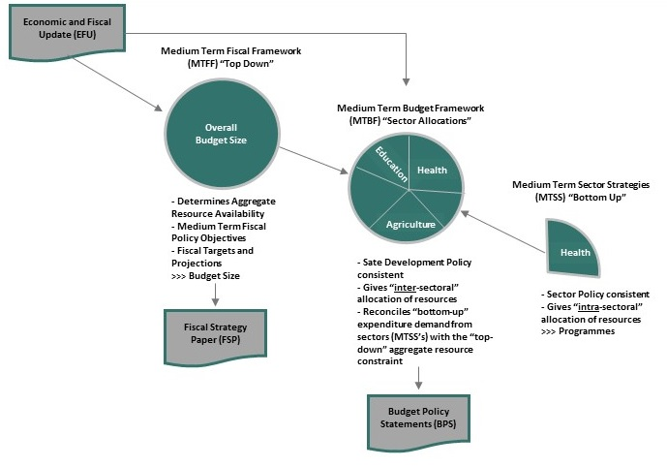

Summary of Document Content
- In accordance with international best practice in budgeting, the production of a combined Economic and Fiscal Update (EFU), Fiscal Strategy Paper (FSP) and Budget Policy Statement (BPS) is the first step in the budget preparation cycle for Benue State Government (BNSG) for the period 2027-2029.
- The purpose of this document is threefold:
- To provide a backwards-looking summary of key economic and fiscal trends that will affect the public expenditure in the future - Economic and Fiscal Update;
- To set out medium-term fiscal objectives and targets, including tax policy; revenue mobilisation; level of public expenditure; deficit financing and public debt - Fiscal Strategy Paper and MTFF; and
- Provide indicative sector envelopes for the period 2027-2029, which constitute the MTBF.
- The EFU is presented in Section 2 of this document. The EFU provides economic and fiscal analysis to inform the budget planning process. It is aimed primarily at budget policy makers and decision makers in the Benue State Government. The EFU also provides an assessment of budget performance (both historical and current) and identifies significant factors affecting implementation. It includes:
- Overview of Global, National and State Economic Performance;
- Overview of the Petroleum Sector;
- Trends in budget performance over the last six years.
- The FSP is a key element in the BNSG Medium Term Expenditure Framework (MTEF) process and annual budget process. As such, it determines the resources available to fund the Government’s growth and poverty reduction programme from a fiscally sustainable perspective.

Preparation and Audience
- The purpose of this document is to provide an informed basis for the 2027-2029 budget preparation cycle for all of the key Stakeholders, specifically:
- State House of Assembly (SHoA);
- Executive Council (ExCo);
- Benue State Budget and Economic Planning Commission;
- Ministry of Finance;
- All Government Ministries, Departments and Agencies (MDAs);
- Civil Society.
- The document is prepared within the first two quarters of the year before the annual budget preparation period. It is prepared by the Benue State Government (EFU-FSP-BPS) Working Group using data collected from International, National and State organisations.

Background

Legislative and Institutional Arrangements for PFM
- Legislative Framework for PFM in Benue State – The fundamental law governing public financial management in Nigeria and Benue State is the 1999 Constitution as amended. Sections 120 and 121 of the Constitution provide that all revenues accruing to the Benue State Government shall be received into a Consolidated Revenue Fund (CRF) to be maintained by the Government, and no revenue shall be paid into any other fund, except as authorised by the State House of Assembly (SHoA) for a specific purpose. The withdrawal of funds from the CRF shall be authorised by the SHoA through the annual budget or appropriation process. The Governor of Benue State shall prepare and lay expenditure proposals for the coming financial year before the SHoA, and the SHoA shall approve the expenditure proposal by passing an Appropriation Law. The Appropriation Law shall authorise the executive arm of government to withdraw and spend the amounts specified from the CRF.
- Benue State Legislative Framework for Public Financial Management (PFM) mandates the House of Assembly to control expenditure and audit public funds, alongside state-specific laws like the Fiscal Responsibility Law and various implementing frameworks by the Ministry of Finance and Office of the Auditor General.
- The framework includes legislative approval of the budget, oversight on its execution through reports and audits, and adherence to national laws like the Public Procurement Act.
- The key components of the legislative framework include:
- Public Procurement Commission Law 2020
- Fiscal Responsibility Law 2020
- Debt Management Establishment Law 2020
- Benue State Financial Instructions.
- Appropriation Law passed annually by the Benue State House of Assembly.
- Institutional Framework for PFM in Benue State – The Constitution vests the executive powers of the State in the Governor. The Constitution provides that “the Governor shall cause to be prepared and laid before the House of Assembly at any time before the commencement of each financial year, estimates of the revenues and expenditure of the State for the next following financial year”. The Governor of Benue State exercises his executive powers either directly or through the Deputy Governor, the Commissioners, Special Advisers, Permanent Secretaries, and other officers in the public service of the State.
- Specifically, Benue State Executive Council (ExCO) formulates the policies of the State Government, considers, and recommends the State’s budget to the House of Assembly. On passage, the Governor signs the appropriation bill into law.
- The Benue State Institutional Framework is guided by principles of fiscal discipline, strategic resource allocation and efficient service delivery, like the Benue State Government’s Arrears Clearance Framework.
- The State Budget and Economic Planning Commission oversees the preparation of the budget, both capital and recurrent. It is also in charge of planning (long and medium-term), setting the broad agenda for development. The commission is the organ of the ExCO that formulates and executes fiscal policy. It also coordinates and manages the State’s fiscal policies and all revenue and expenditure profiles of the government.
- The Ministry of Finance is responsible for core treasury functions such as revenue and expenditure management, accounting, fund and cash management. The Ministry of Finance has two important quasi-autonomous agencies, the Office of the Accountant General for the State (OAGS) and the Benue State Internal Revenue Services (BIRS).
- Specific functions of the OAGS include accounting for all receipts and payments of the State Government; supervising the accounts of the State Ministries, Departments, and Agencies (MDAs); collating and preparing Statutory Financial Statements of the State Government and any other Statements of accounts required by the Commissioner for Finance; maintain and operate the accounts of the Consolidated Revenue Fund, development fund, and other public funds and provide cash backing for the operations of the State Government; maintain and operate the State Government’s accounts; conduct routine and in-depth inspection of the books of accounts of State ministries, departments and agencies to ensure compliance with rules, regulations, policy decisions and maintenance of account codes; and formulate and implement the accounting policy of the State Government.
- Benue State Internal Revenue Service is responsible for the generation of government revenue. The Board formulates and executes Joint Tax Board (JTB) policies on taxation, stamp duties, and motor vehicle licensing, among others.
- The Debt Management Office manages Benue State public debt, as well as liaising with the Debt Management Office at the Federal level.
- Another important institutional framework in the circle of financial management in the State is the Public Procurement Commission. The commission plays a significant role in ensuring that all MDAs adhere to the best practices in procurement.
- Benue State Fiscal Responsibility Commission is responsible for monitoring compliance with the State`s appropriation law. It is to ensure that expenditures incurred are provided for in the annual budget derived through the State’s Development Plan.

Overview of Budget Calendar
- Indicative Budget Calendar for Benue State Government is presented below:
Table 1: Budget Calendar
Stage | Date(s) | Responsibility
Sector Performance Review (Previous Year) | January – February | Ministry of Finance, Benue State Budget & Economic Planning Commission, MDAs
Draft Medium-Term Expenditure Framework (MTEF) & Fiscal Strategy Paper (FSP) | July – August | Benue State Budget & Economic Planning Commission, Ministry of Finance
Issuance of Budget Call Circular | July – August | Benue State Budget & Economic Planning Commission
MDA Budget Preparation | September – October | All Ministries, Departments & Agencies (MDAs)
MDA–Budget Office Bilateral Discussions | October | Benue State Budget & Economic Planning Commission, MDAs
Submission of Draft Budget to State Executive Council (SEC) | September | Benue State Budget & Economic Planning Commission
Presentation of Appropriation Bill to the House of Assembly | November | Governor
Legislative Review & Public Hearings | November – December | House of Assembly
Passage of Appropriation Bill | December | House of Assembly
Assent of Appropriation Bill | December | Governor

Economic and Fiscal Update

Economic Overview

Global Economy
- The International Monetary Fund’s (IMF’s) July 2026 World Economic Outlook (WEO) Update projects global growth at 3.0 per cent for 2026 and 3.4 per cent in 2027. While the OECD's September 2026 outlook projects 2.9% and 3.0%, respectively. The World Bank's June assessment is more cautious, projecting 2.5% growth in 2026, reflecting the effects of the Middle East conflict and higher energy prices.

- Global headline inflation is expected to rise. The IMF projects global headline inflation to rise from 4.1% in 2025 to 4.7% in 2026, before declining to 3.9% in 2027. The OECD similarly expects G20 inflation to reach approximately 4.1% in 2026, before easing to 3.6% in 2027. This creates a difficult policy environment for central banks: reducing interest rates too quickly could prolong inflation, while keeping rates high for too long could weaken investment, consumption and employment.
- The Middle East conflict and its implications for energy markets have become major factors shaping the 2026 outlook and going into 2027 forcast. Higher energy prices affect the global economy through:
- higher transportation and production costs;
- increased food and agricultural-input prices;
- renewed inflation;
- pressure on household purchasing power;
- higher interest rates;
- increased government expenditure; and
- deterioration in the trade balances of energy-importing countries
32 One of the strongest positive forces in the 2026 global economy is investment in artificial intelligence and related technologies. AI investment is supporting:
- semiconductor production;
- cloud computing;
- data centres;
- telecommunications;
- software;
- digital services;
- productivity-enhancing investment; and
- international trade.
The IMF specifically identifies AI-driven demand as an important factor supporting economies integrated into global technology value chains. The OECD likewise reports that strong AI-related investment is helping sustain production, trade and economic growth
33. International trade remains affected by geopolitical tensions, trade-policy uncertainty and supply-chain adjustments.
Countries and businesses are increasingly seeking to:
- diversify suppliers;
- shorten supply chains;
- establish alternative production locations;
- increase strategic inventories; and
- reduce exposure to geopolitical disruptions.
- With these forces in place, the global economy has continued to hold steady, although the composition of economic activity points to distortions arising from tariffs rather than underlying economic robustness. Global growth in the first quarter of 2026 was 0.2% in the July World Economic Outlook (WEO). International trade and investment were the main drivers of activity, while private consumption remained more subdued across major economies
- Real GDP decreased in the United States. Recent activity has been relatively firm. The U.S. Bureau of Economic Analysis reported that real GDP increased at a 2.2% annualized rate in Q2 2026.
- Imports and business investment surged—especially in information processing equipment. Taken together, these patterns were consistent with aggressive front-loading by US firms and households ahead of expected higher prices induced by tariffs.
- . In the euro area, GDP expanded by 0.6 per cent quarter-on-quarter in the second quarter of 2026, following stagnation in the first quarter. Growth was supported particularly by net exports and household consumption, while investment made a more limited contribution. Ireland continued to generate substantial volatility in the regional data, with GDP rebounding by 10.2 per cent quarter-on-quarter in the second quarter after a 7.8 per cent contraction in the first quarter. Excluding Ireland's highly volatile multinational sector, underlying domestic activity remained considerably more moderate.
- China's real GDP grew by 4.3 per cent year-on-year in the second quarter of 2026, slowing from 5.0 per cent in the first quarter. Activity continued to be supported by strong exports, particularly in high-technology goods, while domestic demand remained comparatively weak. The IMF has noted that real depreciation of the renminbi has supported export competitiveness, while strong net exports have partly offset softer domestic demand. Fiscal and other policy measures have continued to support consumption and investment, although the IMF projects China's full-year real GDP growth at around 4.5 per cent in 2026.
- Economic policy and geopolitical uncertainty are expected to remain elevated through 2026 and into 2027. The global economic outlook has been significantly influenced by the conflict in the Middle East, disruptions to energy production and transportation, and continuing trade and policy uncertainties. Energy commodity prices are expected to remain substantially above their pre-conflict levels in 2026, with the IMF projecting an average petroleum spot price of around US$89 per barrel, about 32 per cent higher than in 2025.
- Oil prices rose sharply following disruptions associated with the conflict and concerns over the security of energy supplies and transportation routes, particularly through the Strait of Hormuz. Although some of the initial risk premium has subsequently eased, uncertainty remains high. At the same time, weaker global demand and adjustments in oil consumption are expected to place downward pressure on prices over the course of the outlook. The International Energy Agency projects global oil demand to decline by 2.5 million barrels per day in 2026, reflecting prolonged disruptions and weaker consumption, with demand expected to recover in 2027.
- Prices for natural gas have remained relatively contained amid expectations of lower energy demand resulting from trade uncertainty, news of European Union plans for more flexible targets about storage filling, and the prospects of ample increases in liquid natural gas supply in the medium term.
- Monetary policy is expected to remain differentiated across the major advanced economies in 2026, reflecting differences in inflation dynamics, economic activity and the effects of the energy shock. In the United States, the Federal Reserve is expected to maintain a relatively cautious easing cycle, with the federal funds rate projected to reach around 3¼–3½ per cent by the end of 2026. In the euro area, monetary policy is expected to remain relatively accommodative, although the ECB is projected to raise its policy rate by 25 basis points to around 2.5 per cent by the end of 2026. In Japan, monetary policy is expected to continue its gradual normalisation, while the Bank of England is expected to balance subdued economic activity against persistent inflationary pressures.
- Fiscal policy is expected to provide varying degrees of support across major economies in the near term. In the United States, tax and spending measures enacted in 2025 are projected to provide a modest boost to economic activity in 2026–27, while increasing the fiscal deficit by approximately 1½ percentage points of GDP. Higher tariff revenues are expected to partly offset the deficit impact of these measures. Nevertheless, US fiscal deficits are projected to remain elevated, with the medium-term fiscal position reflecting both the persistence of higher spending and the eventual expiration of some tax provisions.
- The economic outlook (GDP growth rate and inflation rate) of selected countries is shown in Tables 2 and 3 below.
- Countries selected are chosen to represent G20, BRINCS, MINT, N-11, Petro-economies and other large African countries.
Table 2: Real GDP Growth - Selected Countries
Country | Actual |  |  |  | Forecast
Country | 2023 | 2024 | 2025 | 2026 | 2027 | 2028 | 2029
Mexico | 3.3 | 1.5 | -0.3 | 1.4 | 1.9 | 1.9 | 2
Indonesia | 5 | 5 | 4.7 | 4.7 | 5.1 | 5.1 | 5.2
Turkey | 5.1 | 3.2 | 2.7 | 3.2 | 3.6 | 3.5 | 3.5
United States | 2.9 | 2.8 | 1.8 | 1.7 | 2.2 | 2.1 | 2
Germany | -0.3 | -0.2 | 0 | 0.9 | 1 | 1.1 | 1.1
United Kingdom | 0.4 | 1.1 | 1.1 | 1.4 | 1.3 | 1.3 | 1.3
China | 5.4 | 5 | 4 | 4 | 4.1 | 3.9 | 3.7
Ghana | 3.1 | 5.7 | 4 | 4.8 | 4.9 | 4.9 | 4.9
South Africa | 0.7 | 0.6 | 1 | 1.3 | 1.3 | 1.4 | 1.5
Brazil | 3.2 | 3.4 | 2 | 2 | 2.2 | 2.1 | 2.1
Angola | 1 | 4.5 | 2.4 | 2.1 | 2.6 | 2.8 | 3
Nigeria | 2.9 | 3.4 | 3.4 | 3.2 | 4 | 4 | 4.1
Source: IMF’s World Economic Outlook.
Table 3: Inflation (CPI) - Selected Countries
Country | Actual |  |  |  | Forecast
Country | 2023 | 2024 | 2025 | 2026 | 2027 | 2028 | 2029
Mexico | 5.5 | 4.7 | 3.5 | 3.2 | 3 | 3 | 3
Indonesia | 3.7 | 2.3 | 1.7 | 2.5 | 2.5 | 2.5 | 2.5
Turkey | 53.9 | 58.5 | 35.9 | 22.8 | 16.5 | 15 | 12
United States | 4.1 | 3 | 3 | 2.5 | 2.1 | 2.2 | 2.2
Germany | 6 | 2.5 | 2.1 | 1.9 | 2.1 | 2.2 | 2.2
United Kingdom | 7.3 | 2.5 | 3.1 | 2.2 | 2 | 2 | 2
China | 2.0 | 0.2 | 0.2 | 0.0 | 0.6 | 1.4 | 1.8
Ghana | 31.9 | 39.2 | 22.9 | 17.2 | 9.4 | 8.0 | 8.0
South Africa | 6.9 | 5.9 | 4.4 | 3.8 | 4.5 | 4.5 | 4.5
Brazil | 9.3 | 4.6 | 4.4 | 5.3 | 4.3 | 3.4 | 3.0
Angola | 21.4 | 13.6 | 28.2 | 22.0 | 16.4 | 11.5 | 10.0
Nigeria | 18.8 | 24.7 | 33.2 | 26.5 | 37 | 17.6 | 17.3
Source: IMF’s World Economic Outlook.

Africa
- The African Economic Outlook 2025, Africa’s economic performance improved in 2024, but growth remains fragile amidst multiple shocks and rising global uncertainty. Average real gross domestic product (GDP) growth picked up marginally from 3.0 per cent in 2023 to 3.3 per cent in 2024, buoyed by strong government spending and private consumption.
- The growth uptick in 2025 was evident in 29 of 54 African countries. In addition, 10 African countries, including Angola, Ghana, Niger, and Uganda, saw growth increases of more than 1.0 percentage points from 2023 to 2024. However, this slight improvement was overshadowed by persistent inflationary pressures, currency depreciations and high debt service costs. Deepening geopolitical fragmentation, regional conflicts, and rising global uncertainty, spurred by emerging trade policies in several countries, further cloud the outlook for the short and medium terms.
- The IMF’s 2026 Africa Economic Outlook underscores a critical turning point for Sub-Saharan Africa (SSA). While the region demonstrated resilience in 2024 with growth at 4.0%, this momentum has been disrupted. The 2027 projection of 4.% reflects heightened vulnerability due to global trade frictions, tighter financial conditions, and falling commodity prices. This deceleration threatens to stall poverty reduction efforts, widen fiscal imbalances, and erode recent developmental gains.
- A central area of concern is the region’s growing debt burden. As of early 2026, public debt in Sub-Saharan Africa averages over 60% of GDP, and debt servicing costs have risen sharply. In many countries, debt service now absorbs more than 40% of government revenues, placing immense pressure on public budgets and crowding out vital investments in social services and infrastructure. Given the reliance on non-concessional contributions, the IMF outlines several key levers through which governments can improve revenue performance: Broadening the tax base: Many SSA countries operate with narrow tax bases due to large informal economies. Expanding formalisation through simplified tax regimes, better data collection, and incentives for registration is essential to capturing a larger share of economic activity. Borrowing and the limited availability of long-term, affordable capital exacerbate fiscal vulnerabilities, particularly for countries without robust sovereign credit profiles.
- In response, the IMF stresses the urgent need for robust domestic resource mobilisation not only to restore fiscal stability but to create fiscal space for development and resilience-building. However, the current landscape reveals persistent underperformance: the average tax-to-GDP ratio in SSA remains below 16%, still below pre-pandemic levels and significantly lower than in other regions—19.3% in Asia and the Pacific, 21.5% in Latin America and the Caribbean, and 34.0% in OECD countries. This revenue shortfall limits governments’ ability to fund essential services and respond to shocks.
- Despite the potential, revenue mobilisation is not without its political and social risks. Poorly designed or regressive tax policies can increase inequality, provoke resistance, or deepen informality. As such, the IMF advocates for inclusive and progressive tax systems, underpinned by transparency, accountability, and public trust. Simultaneously, the need to build fiscal and external buffers is more urgent than ever. Reserves, contingency financing arrangements, and prudent expenditure management are critical tools for reducing vulnerability to external shocks, whether financial, climatic, or geopolitical. Countries that lack such buffers risk being forced into pro-cyclical spending cuts just when social protection and public investment are most needed.

Nigerian Economy

Macroeconomic
- Nigeria has implemented major reforms over the last two years, which have impacted monetary and fiscal stability and economic resilience:
- The Naira exchange rate has settled in the range of 1,500 to 1,600 after the harmonisation of exchange rate regimes and the free-floating of the Naira
- The fuel subsidy has been removed, freeing up trillions of Naira to support the budgets of Federal, State and Local Governments, and for interventions aimed at the most vulnerable
- Real GDP growth is stable, and Inflation is on a downward trend.
- Crude Oil production is close to the 1.5 Million Barrels Per Day (MBPD) threshold of Nigeria’s OPEC quota. Including lease condensates, production is close to 1.7 MBPD over the first half of 2025

- The passage of the four Tax Acts in mid-2025 – Nigeria Tax Act 2025, Nigeria Tax Administration Act 2025, the Joint Revenue Board of Nigeria (Establishment) Act 2025 and the Nigeria Revenue Service Establishment Act 2025. These lay the foundation for improved tax administration, a fairer pro-growth tax regime, which should ultimately result in increases in economic growth and an increased Tax to GDP ratio (providing the government with more resources) over the medium term.
- The past 24 months have been characterised by significant policy shifts that have reshaped the macro-fiscal landscape in Nigeria – not least the free float of the Naira, the official policy of fuel subsidy (Premium Motor Spirit (PMS) Under Recovery) removal, and FGN’s movement away from using Central Bank of Nigeria (CBN) Ways and Means borrowing to fund its revenue shortfalls. These domestic policy changes have had profound impacts on the country’s macro-fiscal performance.
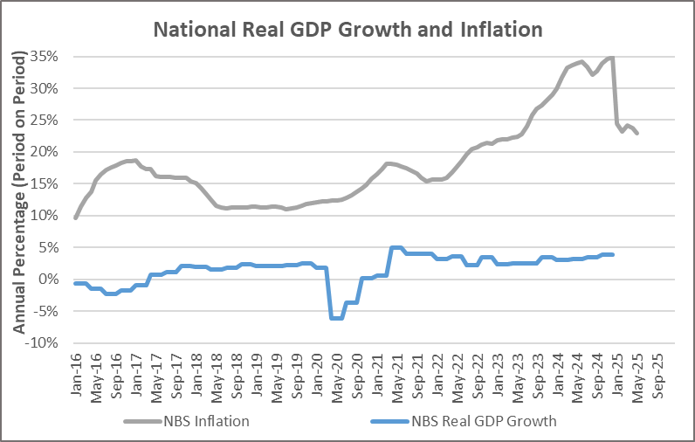
- Steadily increasing real GDP growth and rebased CPI inflation – after a brief dip in Quarter 1 of 2024, real GDP growth has crept up quarter by quarter over the remainder of 2024, from 2.98% in quarter 1 to 3.84% in quarter 4 and 3.13 in quarter 1, 2025, providing an overall growth rate of 3.40% for 2024, up from 2.74% in 2023. Transport and financial services were two of the largest contributors to the increased growth. A slight uptick in crude oil production also provided a positive contribution (real growth in the oil sector reached 5.54% in 2024). Worryingly, real agriculture sector growth was weak at 1.19% in 2024.
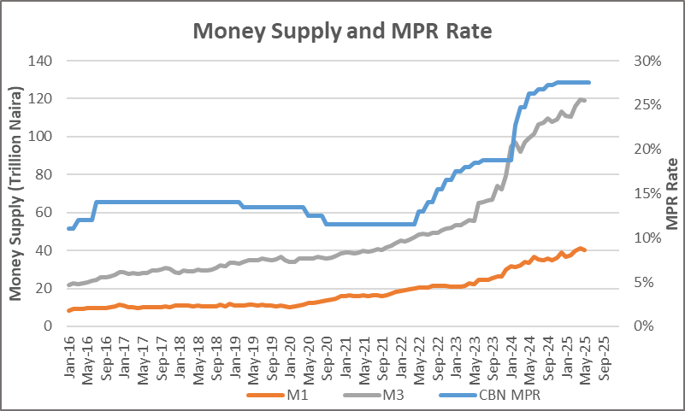
- NBS undertook a Consumer Price Index (CPI) rebased exercise in early 2025, which has resulted in a significant drop in inflation from January 2025 onwards. The rebasing exercise, which was based on household expenditure data from surveys and administrative sources, reduced the weighting on (1) Food and Non-Alcoholic Beverages and (2) Housing, Water, Electricity, Gas and Other Fuels, whilst significantly increasing the weightings for (1) Transport and (2) Restaurants and Accommodation Services. The increased weighting of transport reflects the increased price of PMS. CPI inflation had reached an all-time high of 34.80% in December 2024, before falling back by more than 10% to 24.48% in January 2026 - largely because of the rebasing exercise. By July 2025, the figure had fallen to 21.88% - the lowest rate in two years. This drop was also assisted by the impacts of the 2024 Naira devaluation and the removal of the fuel subsidy, which started to fall out of the CPI inflation figures.
- To combat rising inflation, the Central Bank of Nigeria (CBN) has aggressively raised interest rates over the last 24 months. Since the new Central Bank Governor took office, the Monetary Policy Rate (MPR) has been increased from 18.75% before the first Monetary Policy Committee (MPC) meeting in February 2024 to 27.5% and is currently 23.0 % as at september, 2026. The reduction of Nigeria’s Monetary Policy Rate (MPR) from 26.5% to 23.0% in September 2026 was primarily driven by the CBN’s assessment that the monetary-policy framework needed to be recalibrated to reflect prevailing market conditions, alongside improving inflation and broader macroeconomic conditions
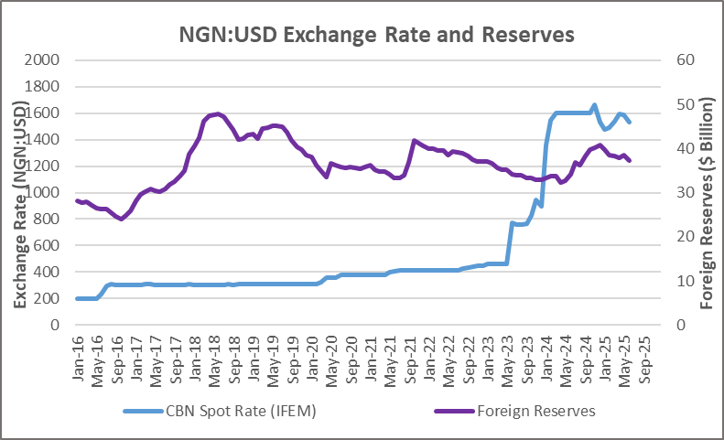
- Stabilisation of the Exchange Rate –after years of multiple exchange rates and the fixing on the official exchange rate far above its market value, the free float of the Naira by the Central Bank of Nigeria (CBN) in mid-2023 saw a series of devaluations that took the Naira from N460 to the US Dollar (USD) in May 2023 to N1,600 to the USD by mid-2024. Over the last 24 months, the rate has stabilised in the region of N1,330 to N1,600, with foreign reserves of $54.9billion. The devaluation has had multiple knock-on economic and fiscal implications – as noted above, inflation surged as the price of imported goods increased, not least PMS, which was also subject to the removal of the subsidy. Foreign debt service costs of Federal and State governments, as well as the naira valuation of foreign debt stocks, are other impact points.
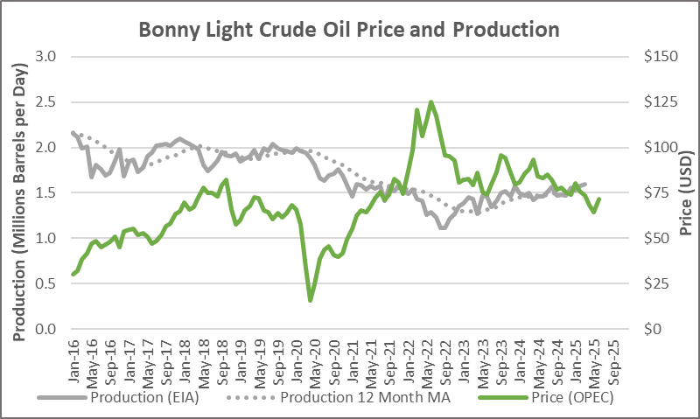
- Flat Crude Oil Price, slight uptick in Crude Oil Production – after the brief spike in crude oil prices in mid-2022 as a result of the conflict in Ukraine (Bonny Light reached a high of $125.22 per barrel in June 2022), prices quickly fell back below the $100 mark by August 2022 as the global economy slowed and demand for crude oil followed suite. Tensions in the Middle East from late 2023 also saw the prices move back towards $100 barrels per day; however, this was short-lived. The price of Bonny Light has been fluctuating within the range of $65 to $103 per barrel ( as at September,2026), with occasional swings of up to $10 in a single day as a result of incidents and political statements related to the ongoing Middle East conflict.
- Crude Oil Production (including lease condensate) has averaged around 1.675 Million Barrels per day (MBPD) over the first six months of 2025, according to figures published by the Nigeria Upstream Petroleum Regulation Commission (NUPRC). These figures are consistent with those published by the US Energy Information Administration (EIA) and the Organisation of Petroleum Exporting Countries (OPEC).
- The 2026 production figure of 1.675 MBPD is higher than the 1.47 MBPD produced in 2023 and 1.55 MBPD in 2024. Around 250,000 barrels of Nigeria’s production are in the form of lease condensate, which does not count towards its 1.5 MBPD OPEC (Organisation of Oil Exporting Countries) production quota. Nigeria is seeking to increase its output to 2.0 MBPD by 2027 amid expectations that production will move closer to its capacity of 2.4MBPD, as stated by the Nigerian National Petroleum Company (NNPC).
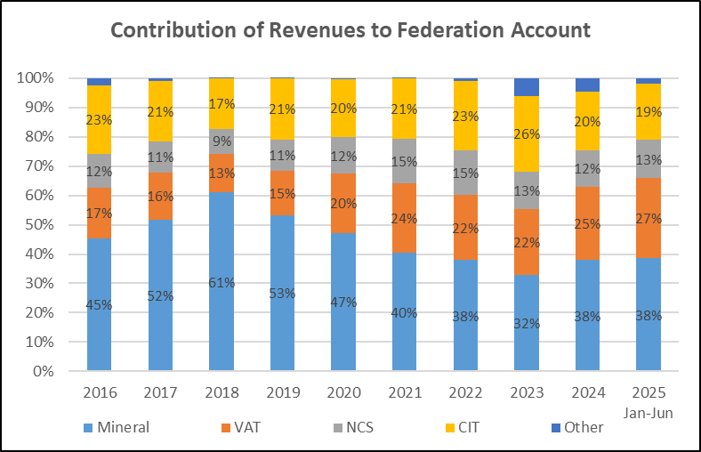
- Decreased reliance on Crude Oil revenues – the trend in the makeup of Federation Account revenues over the last ten years shows a clear reduction of government dependence on mineral sector revenues. This has been both as a result of periods of suppressed global crude oil prices, a sustained period of lower production (less than 1.5 MBPD), as well as the strong growth in non-mineral revenues (far outstripping nominal GDP growth). The increase in the VAT rate from 5% to 7.5% also boosted VAT collections.
- However, there is still a need to maximise the benefit of Nigeria’s crude oil reserves to create fiscal space for critical economic and social structure investments and to boost funding for critical service delivery.
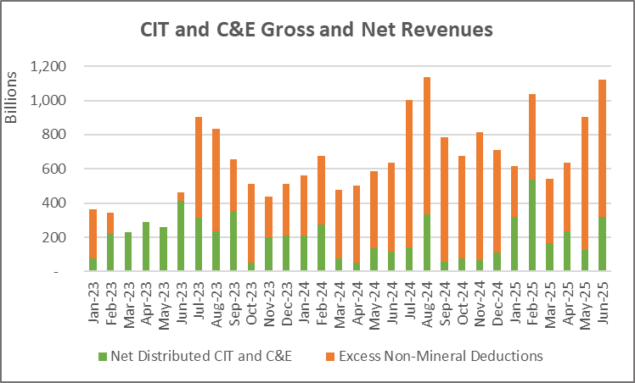
- Reductions in distributable non-Mineral revenues - a significant proportion of CIT and Customs revenues have been deducted from FAAC as “Excess Non-Mineral” over the last 18 months, meaning the growth levels for the gross revenue receipts noted above have not been reflected in Statutory Allocation distributions. The “Excess” deductions are to be made when the revenue in the month exceeds 1/12 of the budgeted revenue in the FGN annual budget and are intended to be used to augment distributions in the months when actual revenues fall short of the budget. However, what has been observed in terms of deductions and distributions of Excess Non-Mineral does not appear to be made in a systematic manner – rather, they have been used to fund various initiatives, including the share of signature bonuses to States, different infrastructure and security initiatives, etc.
- In 2024, a total of N6.9 trillion was deducted as Excess Non-Mineral, whilst a meagre N100 billion was distributed. In the first six months of 2025, N3.16 trillion has been deducted.
- To put these figures into context, the total collection for gross CIT and Customs in the first half of 2025 was N4.85 trillion. So, 65% of the gross accrued revenue has been deducted as excess non-mineral.
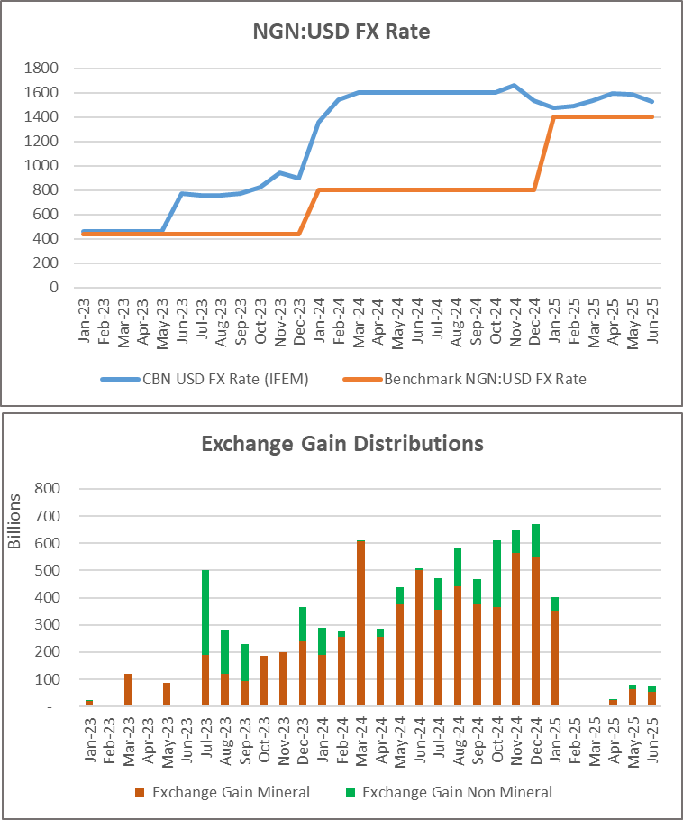
- Exchange Gain – the market exchange rates in 2024 were significantly above the benchmark rates in the FGN 2024-2026 MTEF-FSP document, as a result of the devaluations of the naira as discussed earlier in this section.
- This resulted in higher-than-forecast revenues from transactions based on foreign currencies (imports and exports). This “windfall” is separated from the underlying revenue sources (e.g. Mineral Revenue, Customs, etc) and presented as “Exchange Gain Mineral” and “Exchange Gain Non-Mineral” in the monthly FAAC Schedule 1.
- Exchange Gains, particularly for Mineral revenues, were a significant contributor to Federation Account revenues in 2024. A total of N5.86 trillion was distributed as Exchange Gain in 2024 (N4.83 trillion as Mineral and N1.02 trillion as Non-Mineral). However, as the exchange rate benchmark for 2025 was set close to the market rate (1,500 to the USD), the increased revenues from the deviations are now captured mainly under the standard revenue streams (mineral, CIT and C&E) (albeit there have been some minor exchange gain distributions in the second quarter of 2025).

Benue State Economy
- Benue State, located in Nigeria’s North Central region, boasts a predominantly agrarian economy and is widely recognised as the “Food Basket of the Nation.” Its fertile land, favourable climate, and proximity to the Benue River have positioned it as a leading producer of staple crops and a key contributor to Nigeria’s agricultural output.
- Agriculture is the backbone of Benue’s economy, engaging a majority of the population and contributing significantly to state revenue. Major crops include yams, cassava, maize, rice, and soya beans, with Benue accounting for over 70% of Nigeria’s total soya bean production. The state also produces millet, sorghum, potatoes, and legumes. While subsistence farming remains common, there is a growing shift toward commercial agriculture and agro-processing, supported by government initiatives and private investment.
- Benue’s industrial sector is modest but expanding, with activities centred around food processing, mining, textiles, furniture production, and construction materials. Makurdi, the state capital, serves as the primary commercial hub, followed by Gboko and Otukpo, which facilitate trade in agricultural produce and local crafts. Efforts to develop agro-industrial parks and attract investment in manufacturing are ongoing.
- The state is endowed with a variety of solid minerals, including limestone, clay, gypsum, baryte, coal, and lead. However, the mining sector remains underdeveloped due to limited infrastructure and investment. The government has identified this sector as a strategic area for diversification and is encouraging exploration and private sector participation.
- With an estimated GDP of ₦8.08 trillion based on the recently released data from NBS as of 2023, Benue ranks 11th among Nigeria’s 36 states and holds the largest economy in the North Central region, trailing only Niger State. It also boasts the highest per capita GDP in the region, reflecting its strong agricultural base and growing commercial activity.
- Despite its strengths, Benue faces several economic challenges, including inadequate rural infrastructure, limited access to agricultural financing, underutilization of mineral resources, and periodic herder invasions that disrupt farming activities. These issues hinder productivity and investment.
- In terms of growth opportunities, Benue State has significant potential for economic expansion through:
- Development of agro-processing and value chains
- Investment in solid minerals and mining infrastructure
- Promotion of tourism and cultural heritage
- Expansion of the digital economy and youth entrepreneurship
- Strengthening of Public-Private Partnerships in key sectors

Fiscal Update

Historic Trends

Revenue Side
- On the revenue side, the document looks at Statutory Allocation, VAT, IGR, Excess Crude, and Capital Receipts – budget versus actual for the period 2019-2024 (six-year historic) and 2025 budget.
Figure 2: Statutory Allocation
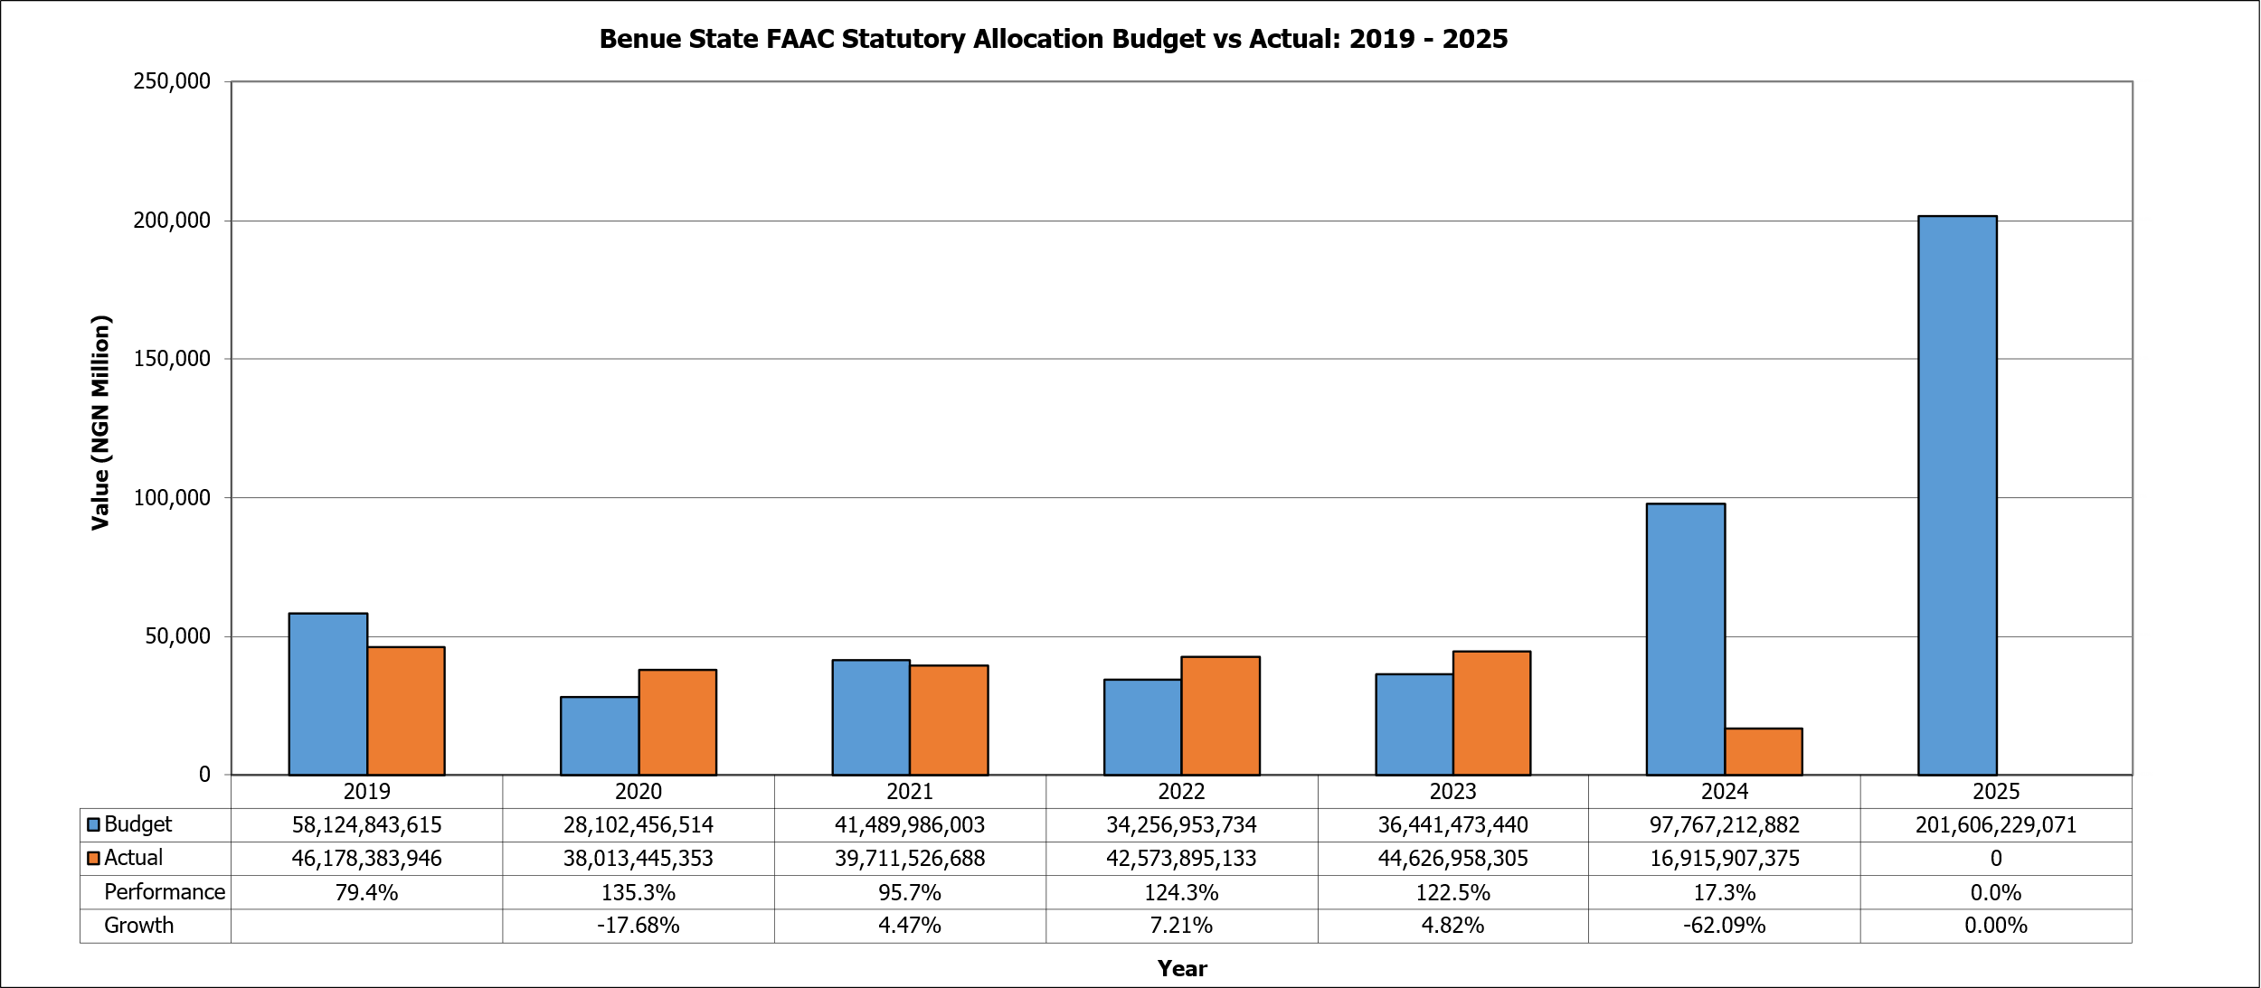
- Figure 2 titled “Benue State FAAC Statutory Allocation Budget vs Actual: 2019–2025” shows the statutory allocation budgeted by Benue State against what was received over the seven years. In 2019, the state budgeted ₦58.12 billion but received only ₦46.17 billion, resulting in a performance rate of 79.4%. In 2020, the budget dropped significantly to ₦28.1 billion, but actual allocation also fell to ₦38 billion, though relatively higher than the budgeted amount. However, the reduction caused a negative growth rate of -17.68% compared to the previous year. This decline was due to the broader macroeconomic challenges, such as reduced national revenue inflows or external shocks like the COVID-19 pandemic. The performance gap persisted into 2021, where, although the budget increased to ₦41.6 billion, actual receipts were ₦39.7 billion, showing a slight recovery with 95.7% performance and a 4.47% growth rate
- From 2022 to 2023, the trend of modest gains continued. In 2022, Benue State budgeted approximately ₦34.3 billion but received ₦42.57 billion, reflecting a surplus leading to a growth rate of 7.21%. Similarly, in 2023, the budget was ₦36.44 billion with actual receipts of ₦44.6 billion, yielding a performance rate of 124.3% and 122.5% performance for 2022 and 2023, respectively. These led to growth rates of 7.21% and 4.82% respectively. The years suggest improvement in actual allocations, over and above the State’s budgetary expectations. However, the budget ballooned to approximately ₦97.8 billion in 2024, yet actual receipts stood at only ₦16.9 billion, representing a drastic decline in revenue growth by -62.09% and the widest gap between budget and actual allocation across the observed period. This sharp discrepancy points to either over-ambitious budget projections, structural fiscal constraints, or severe statutory allocation shortfalls from the federation allocation pool. By 2025, the budget projection increased to ₦201 billion. If historical patterns persist, the State may face funding gaps. The data shows the need for more conservative and evidence-based budgeting, enhanced revenue diversification, and prudent fiscal reforms to align expectations with fiscal realities.
Figure 3: VAT
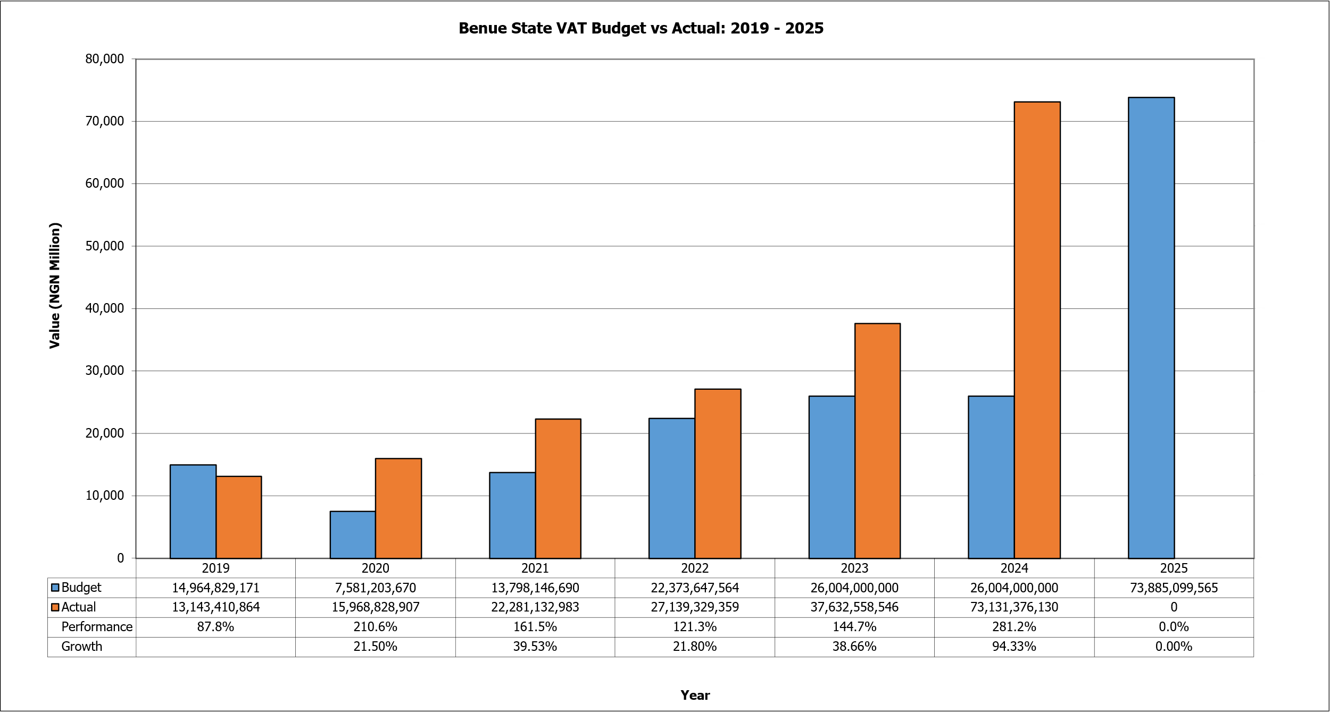
- Figure 4 titled “Benue State VAT Budget vs Actual: 2019–2025” presents the State’s projected Value Added Tax (VAT) revenues and the actual amounts received across the period. This graph shows a consistent pattern of actual revenues surpassing budget projections in most years, indicating conservative budgeting and stronger-than-expected VAT collections. In 2019, the State budgeted about ₦14.96 billion but received ₦13.14 billion, translating to a performance rate of 87.8%. However, in 2020, a remarkable shift occurred. The budget was conservatively pegged at approximately ₦7.58 billion, while actual VAT receipts surged to ₦15.97 billion, representing a staggering 210.6% performance rate. This marked improvement continued into 2021, where the budget stood at ₦13.8 billion while actual VAT receipts hit approximately ₦22.28 billion, reflecting 161.5% performance and strong annual growth of 39.53%.
- From 2022 through 2024, the upward trend in VAT collections persisted. In 2022, actual receipts (₦27.14 billion) exceeded the ₦22.37 billion budget, yielding a performance rate of 121.3%. Similarly, in 2023, VAT collections soared to ₦37.63 billion against a ₦26.00 billion budget, maintaining a strong performance rate of 144.7% with impressive growth of 38.66%. The most striking year was 2024, when actual VAT revenues nearly tripled the projection. Against a budget of ₦26.0 billion, the State received ₦73.1 billion, an extraordinary performance of 281.2% and growth of 94.33%. This massive jump explains the increasing centrality of VAT as a dependable and buoyant revenue source, particularly when compared to statutory allocations, which suffered sharp underperformance in the same year. For 2025, the budget projects a massive ₦73.9 billion in VAT revenues, closely aligned with the 2024 actual receipts. A general observation is that, except for 2019, the actual VAT collections significantly exceeded projections, pointing to a more reliable and buoyant revenue stream for the State compared to statutory allocations.
Figure 4: IGR
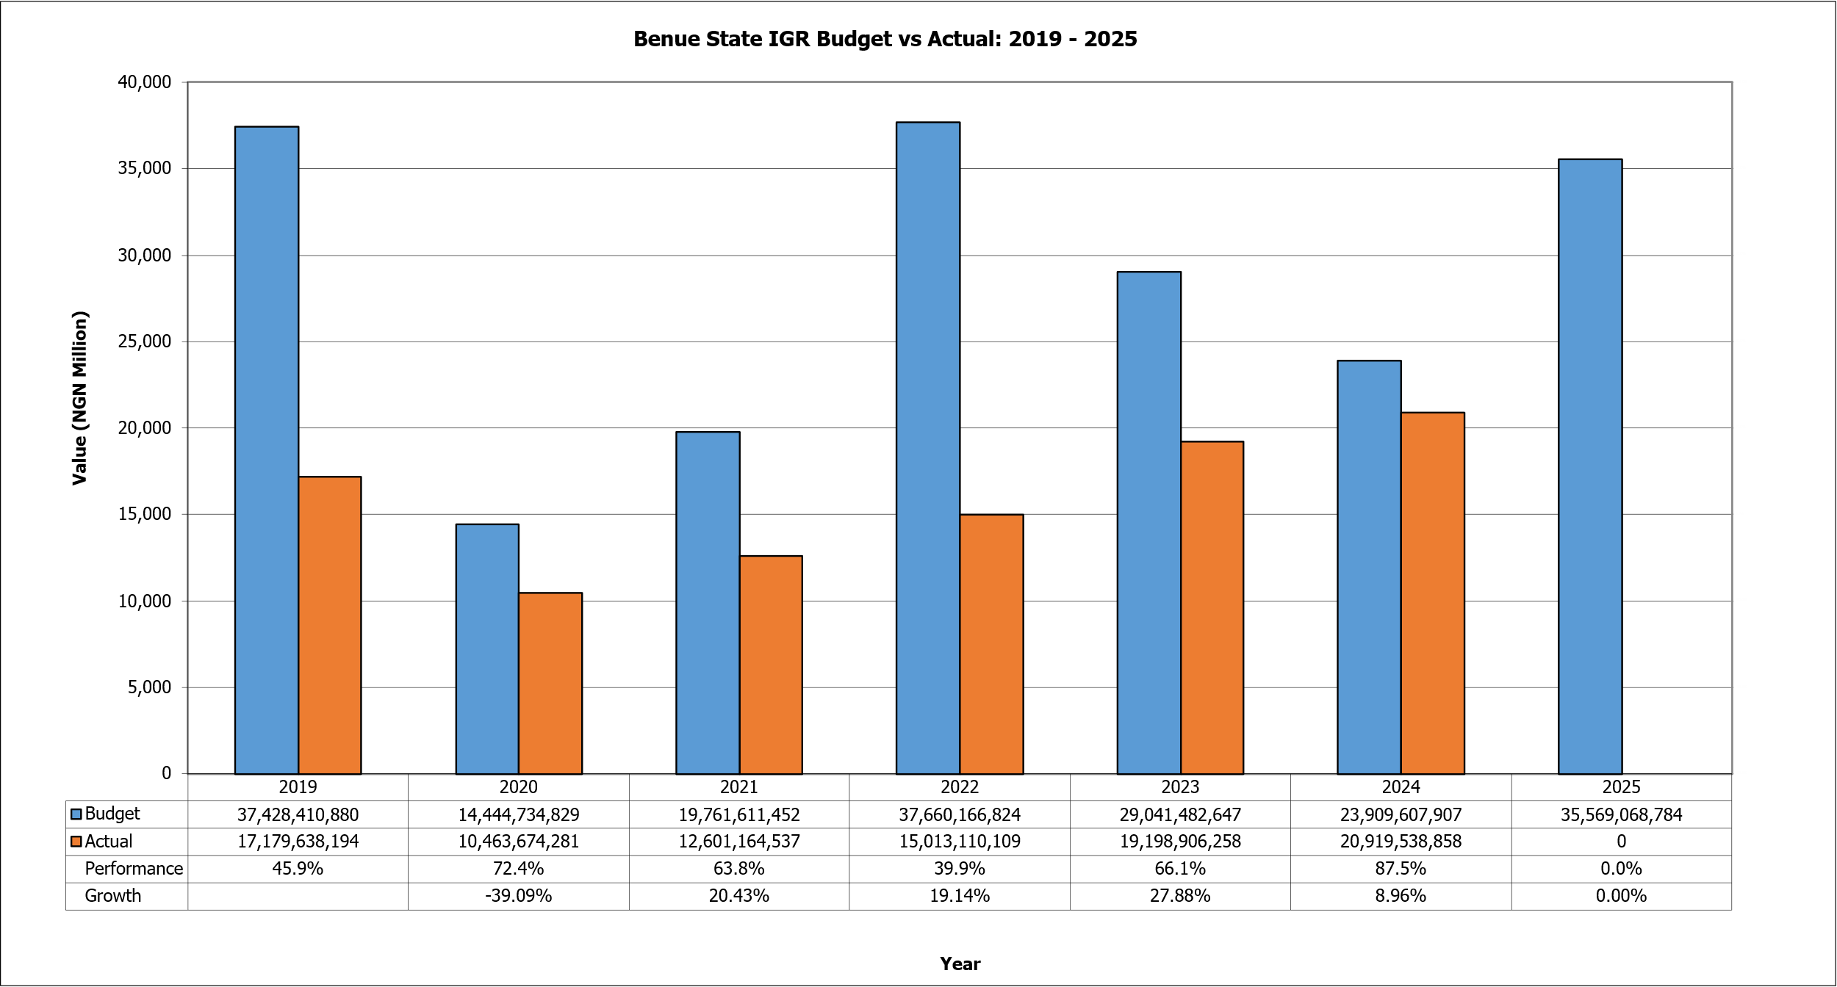
- Figure 4 titled “Benue State IGR Budget vs Actual: 2019–2025” shows the State’s Internally Generated Revenue (IGR) performance over the period. In 2019, Benue State set a high revenue target of ₦37.43 billion but managed to collect only ₦17.18 billion, reflecting a performance rate of 45.9%. Consequently, the situation in 2020 saw a much lower budgeted IGR of ₦14.44 billion, perhaps in recognition of previous underperformance and the expected economic disruptions of the COVID-19 pandemic. Actual collections stood at ₦10.16 billion, yielding a performance rate of 72.4%, which, although still below target, reflected more realistic projections. However, growth compared to the previous year was sharply negative at -39.09%, showing the severe impact of economic contraction and reduced economic activities on IGR. From 2021 to 2023, IGR performance showed modest improvements, but budget-expectation mismatches persisted. In 2021, the budget was ₦19.76 billion, with actual collections of ₦12.6 billion, giving a performance rate of 63.8% and a positive growth of 20.43% compared to 2020. By 2022, the budget increased again to ₦37.66 billion, but actual collections were only ₦15.01 billion, pushing performance down to 39.9%, the lowest across the observed years. In 2023, the budget target was ₦29.04 billion, with actual collections of ₦19.2 billion, marking a better performance rate of 66.1% and growth of 27.88%, indicating gradual improvements in collection efficiency or expansion of the taxable base. In 2024 IGR was budgeted at ₦23.9 billion, which saw receipts of ₦20.9 billion representing 87.5% performance. This indicates 8.96 growth over the previous year.
Figure 5: Other Federation Account Receipts
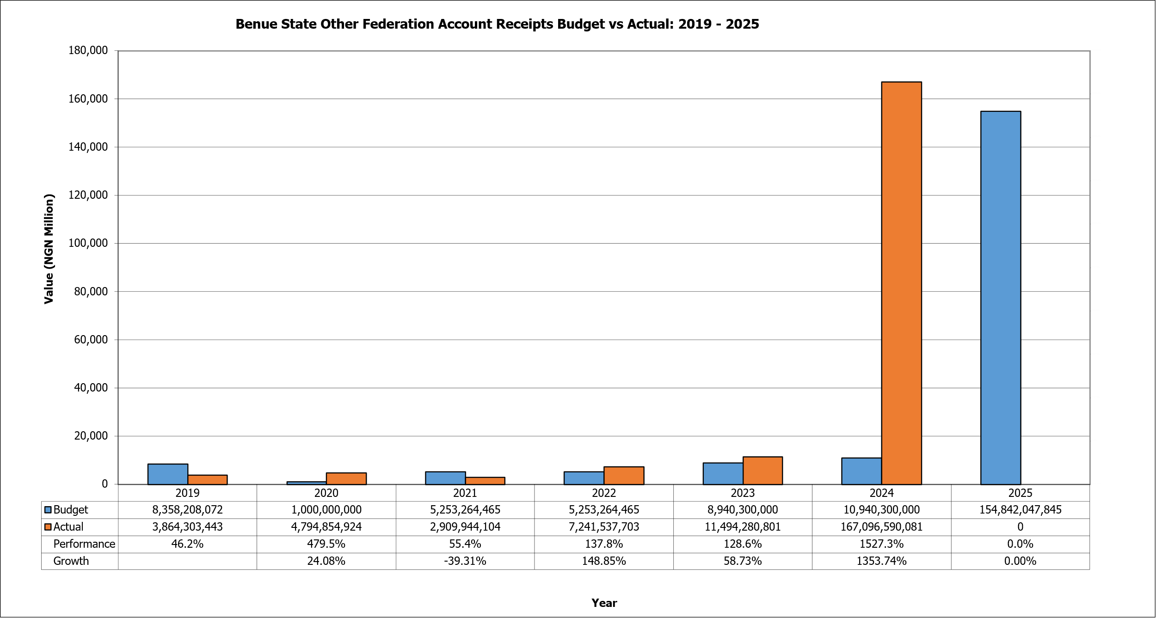
- Figure 5 shows “Benue State Other Federation Account Receipts Budget vs Actual: 2019–2025” presenting the revenue inflows from other components of the Federation Account aside from statutory allocation and VAT. In 2019, the State budgeted ₦8.36 billion but received only ₦3.86 billion, showing a performance rate of just 46.2%. However, in 2020, the state budgeted a modest ₦1.0 billion but received ₦4.79 billion, yielding a remarkable 479.5% performance and 24.08% growth from the previous year. This reflects how conservative budgeting combined with higher-than-expected national disbursements can result in significant overperformance. The trend, however, reversed in 2021 when the budget rose to ₦5.25 billion, but actual receipts dropped to ₦2.91 billion, leading to a performance rate of 55.4% and negative growth of -39.31%. From 2022 onward, the figures depict both recovery and explosive growth.
- In 2022, the budget remained at ₦5.25 billion, while actual receipts rose to ₦7.24 billion, representing 137.8% performance and 148.85% growth compared to the previous year. This positive turnaround continued in 2023, when the budgeted amount increased to ₦8.94 billion and actual collections reached ₦11.49 billion, yielding 128.6% performance and 58.73% growth. However, the most extraordinary year was 2024 when the budgeted figure was ₦10.94 billion, yet actual receipts skyrocketed to an unprecedented ₦167.1 billion. This represents a staggering 1527.3% performance and an astronomical growth rate of 1353.74% compared to the previous year. The high inflow of other Federation Account receipts was due to high performance of exchange gains and the electronic money transfer levy (EMTL). Looking ahead to 2025, the State has budgeted a massive ₦154.8 billion in anticipation of continued high inflows, which is unlikely. A striking feature of this graph is the high volatility in actual collections relative to budgets, with performance swinging from significant underperformance in some years to dramatic overperformance in others. This inconsistency shows the unpredictability of this revenue source, which may stem from the irregular nature of inflows such as exchange rate differentials, excess crude proceeds, or intervention funds.
Figure 6: Grants
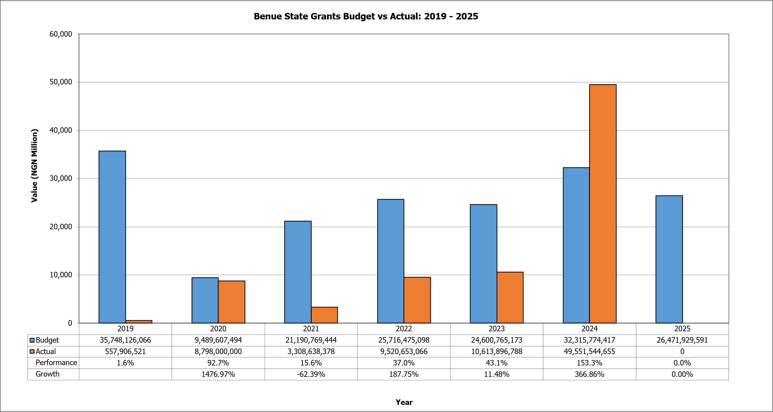
- Figure 6 shows the Benue State grants budget versus actual receipts from 2019 to 2025. In 2019, the budgeted amount was approximately ₦35.75 billion, yet the State only realised around ₦557.91 million. This represents a performance of just 1.6%, highlighting a major shortfall in expected grants inflows. However, the picture changed dramatically in 2020 when the performance surged to 92.7%, with ₦8.8 billion actual receipts against the ₦9.19 billion budget. From 2021 to 2023, actual performance continued to fluctuate, though at higher levels than in 2019. In 2021, only ₦3.31 billion was received against ₦21.19 billion budgeted, yielding a performance of 15.6%. However, this was followed by stronger performance in 2022, when ₦9.52 billion was collected against ₦25.72 billion budgeted, reaching 37%. This upward trend carried over into 2023, with ₦10.61 billion realised from ₦24.6 billion budgeted, giving a performance rate of 43.1%. While these amounts still fall short of meeting the full budget, they suggest incremental improvements in grant collection capacity, indicating either stronger negotiations with partners or better alignment of budgets with realistic grant expectations.
- The standout year in the trend is clearly 2024. Benue State budgeted ₦32.32 billion but remarkably achieved ₦49.55 billion in actual grants, overshooting its budget by a wide margin and resulting in a performance level of 153.3%. This sharp turnaround from the preceding years demonstrates extraordinary growth in grant inflows, recorded at 366.86% compared to 2023. Such a performance could be attributed to expanded donor interest, improved project designs that attracted more funding, or stronger institutional capacity to access external resources. In 2025, the budget has been set at ₦26.47 billion. The historical trend suggests that performance can be erratic, ranging from as low as 1.6% in 2019 to as high as 153.3% in 2024. This unpredictability reflects the challenges of relying heavily on grants as a revenue stream, given their dependence on external funding bodies, conditionalities, and broader economic and political factors.
Figure 7: Other Capital Receipts
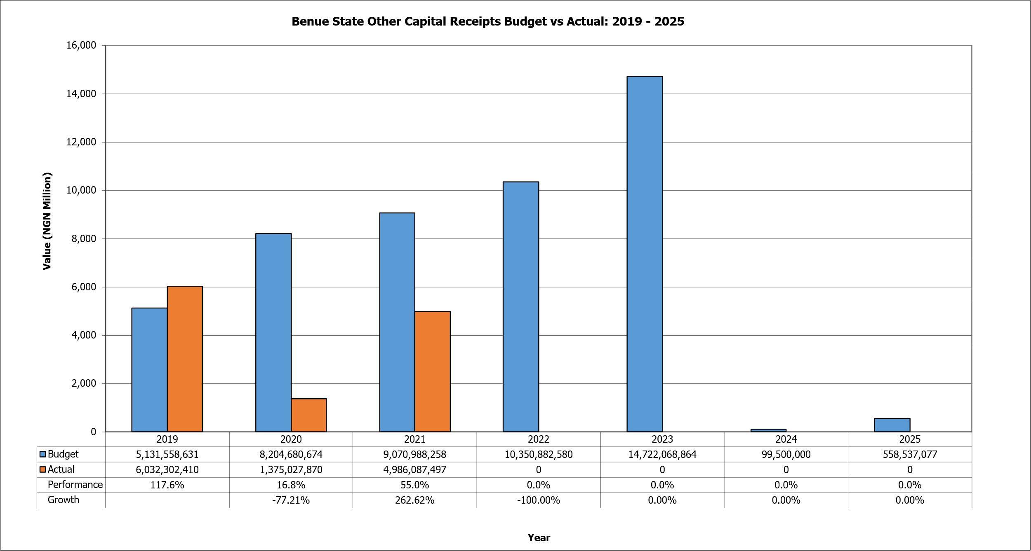
- The graph in Figure 7 presents the Other Capital Receipts from Benue State using the budgeted versus actual receipts from 2019 to 2025. In 2019, the State budgeted ₦5.13 billion but actually received ₦6.03 billion, resulting in a performance rate of 117.6%. This is the only year in the series where actual receipts exceeded the budget. In 2020, the situation shifted sharply. The budget increased significantly to ₦8.2 billion, but actual receipts dropped to just ₦1.38 billion, yielding a performance of only 16.8%. This represented a steep 77.2% decline compared to the previous year. The year 2021, however, brought some recovery, with actual receipts of ₦4.99 billion against a budget of ₦9.07 billion. This performance level of 55% was far from perfect but indicated that the State was able to mobilise a more meaningful share of its expected receipts compared to 2020. The 262.6% growth compared to the previous year shows this rebound, even though the actual values still lagged significantly behind budgeted targets.
- The real collapse occurs from 2022 onward. Despite steady or even rising budgets to ₦10.35 billion in 2022 and ₦14.72 billion in 2023, no actual receipts were recorded, bringing performance down to 0% for multiple consecutive years. This trend persisted in 2024, where, despite a symbolic budget entry of just ₦99.5 million, actual receipts remained zero. The same is true for 2025 so far, though the actual data are yet to be collected. This prolonged pattern of non-performance raises important questions about the viability of “Other Capital Receipts” as a dependable revenue line in Benue State’s budgetary framework.
Figure 8: Loans/Financing
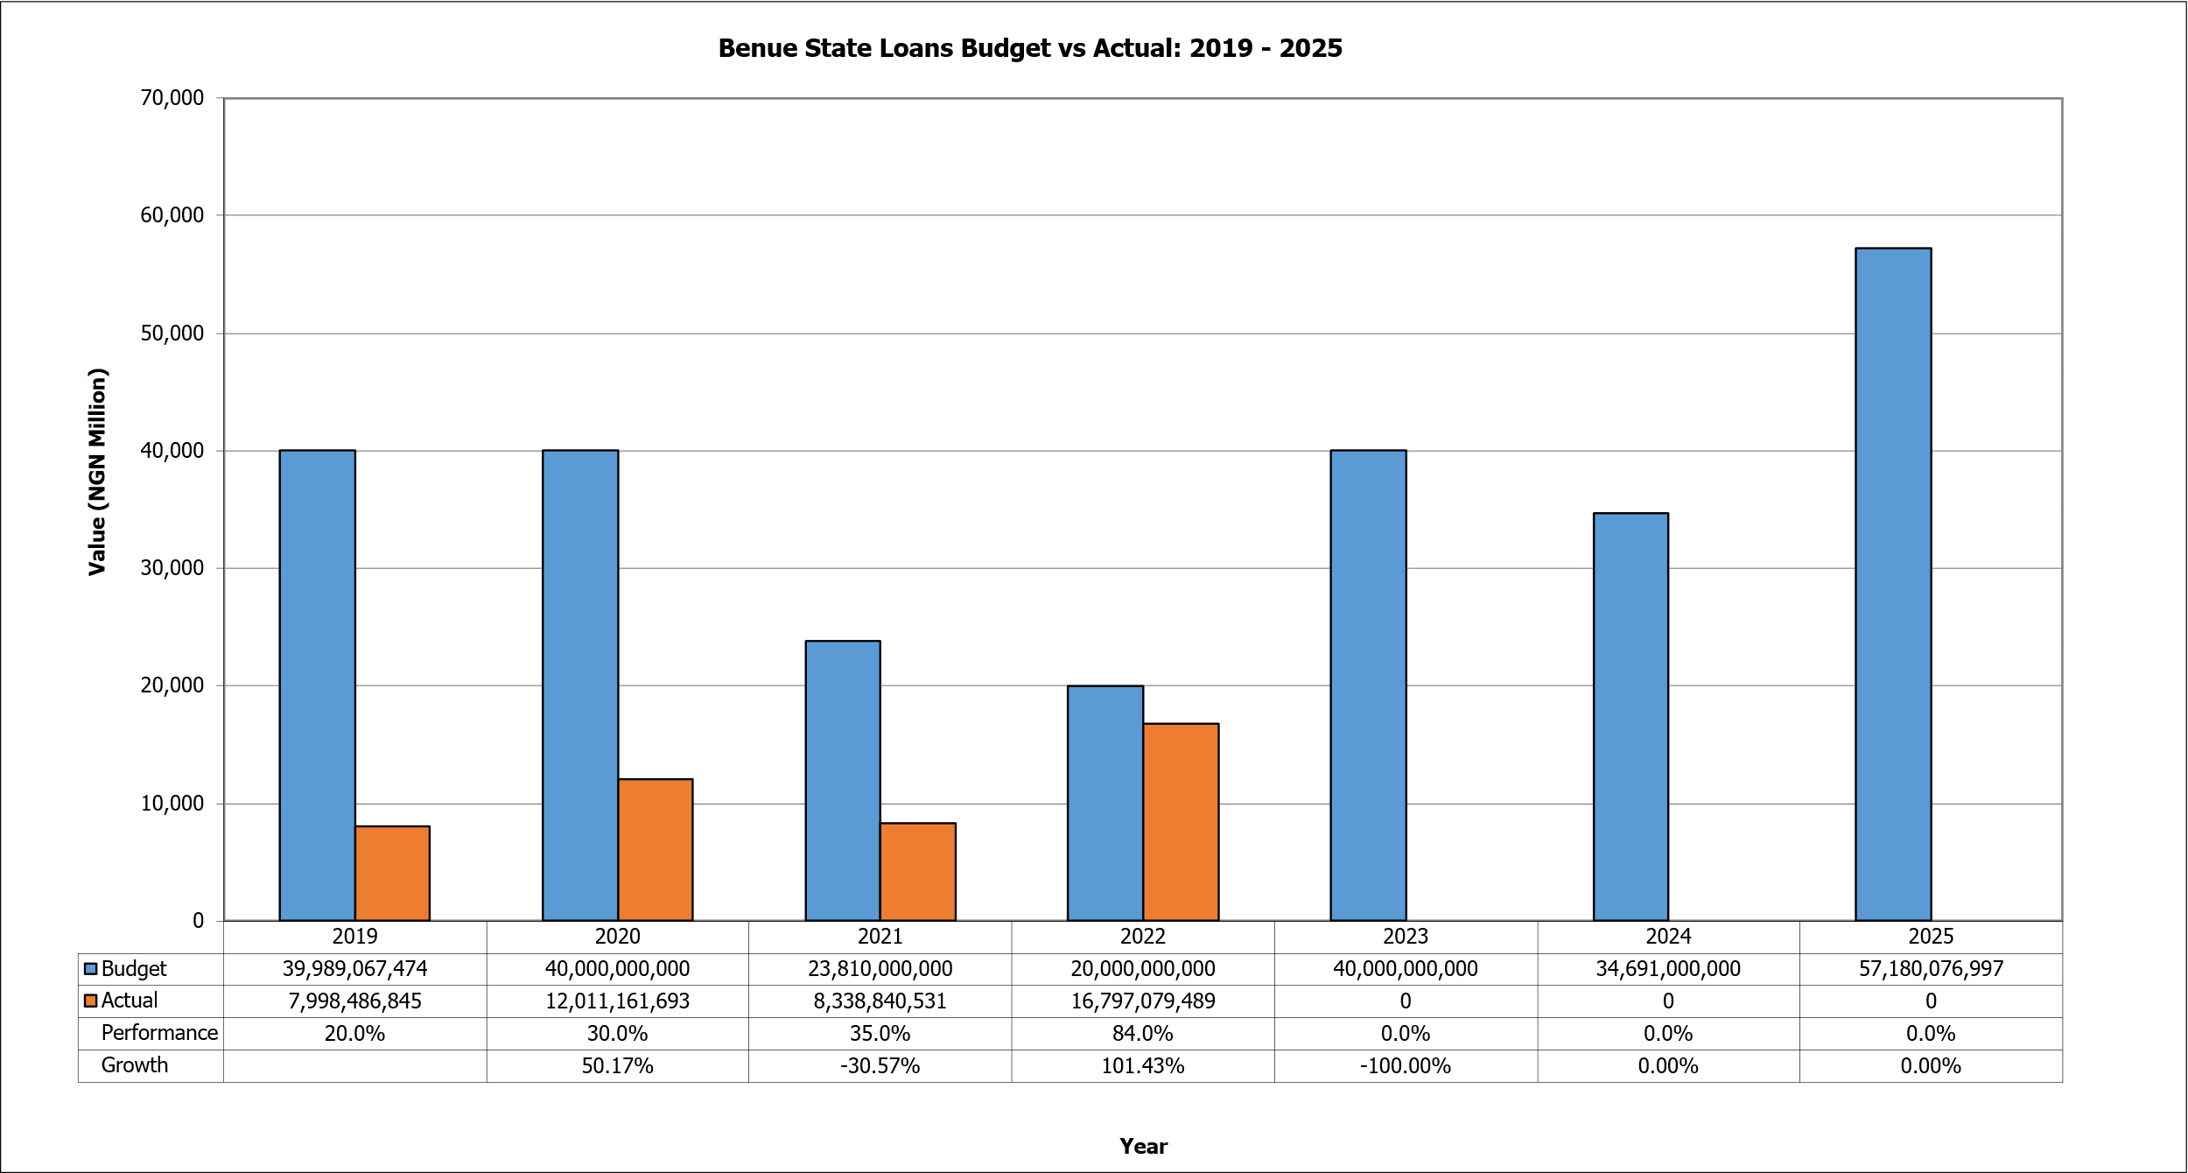
- Figure 8 shows the Benue State loans budget versus actual financing from 2019 to 2025. In 2019, the State projected to secure loans worth approximately ₦39.99 billion, but only ₦7.99 billion was actually obtained. This translated to a performance rate of just 20.0%. By 2020, however, the situation improved slightly, with ₦12.01 billion received against a ₦40 billion budget, representing a performance of 30.0%. This upward trend suggested an enhanced ability to access loans, even though the actual amounts continued to fall significantly short of budgetary estimates. In 2021, the loan budget was reduced to ₦23.81 billion, but the State only secured ₦8.34 billion, yielding a performance of 35.0%. While the budget cut indicated more conservative planning, actual performance still hovered below 40%, reflecting persistent financing shortfalls. In 2022, against a ₦20 billion budget, the State realised ₦16.8 billion, giving an impressive performance rate of 84.0%. This surge represented a growth rate of 101.43% from the previous year, showing a significantly improved loan access, possibly due to favourable credit conditions or increased borrowing needs to finance expenditure pressures. The trend reversed in 2023 when, despite budgeting ₦40 billion for loans, the State recorded zero actual receipts. This resulted in a performance of 0.0%, pointing to either a deliberate policy shift away from loans or an inability to secure external financing despite high budgetary projections. Although, ₦34.69 billion was budgeted in 2024 to address the fiscal gaps, however, nothing was secured in this regard. The reason was to enhance the state’s debt sustainability ratio, as well as observe the extent to which statutory inflows and IGR could be invested into state infrastructure for development. This further provided a clear borrowing path on what is actually needed as borrowed funds for public investment. To this extent, by 2025, the borrowing plan was set at ₦57.18, but later supplemented at ₦107.1 billion given changes in government priorities as well as expanded access to domestic and external lenders.

Expenditure Side
- On the expenditure side, the document looks at Consolidated Revenue Fund (CRF) charges, Personnel, Overheads and Capital Expenditure – budget versus actual for the period 2019-2024 (six years) and 2025 budget.
Figure 9: Personnel
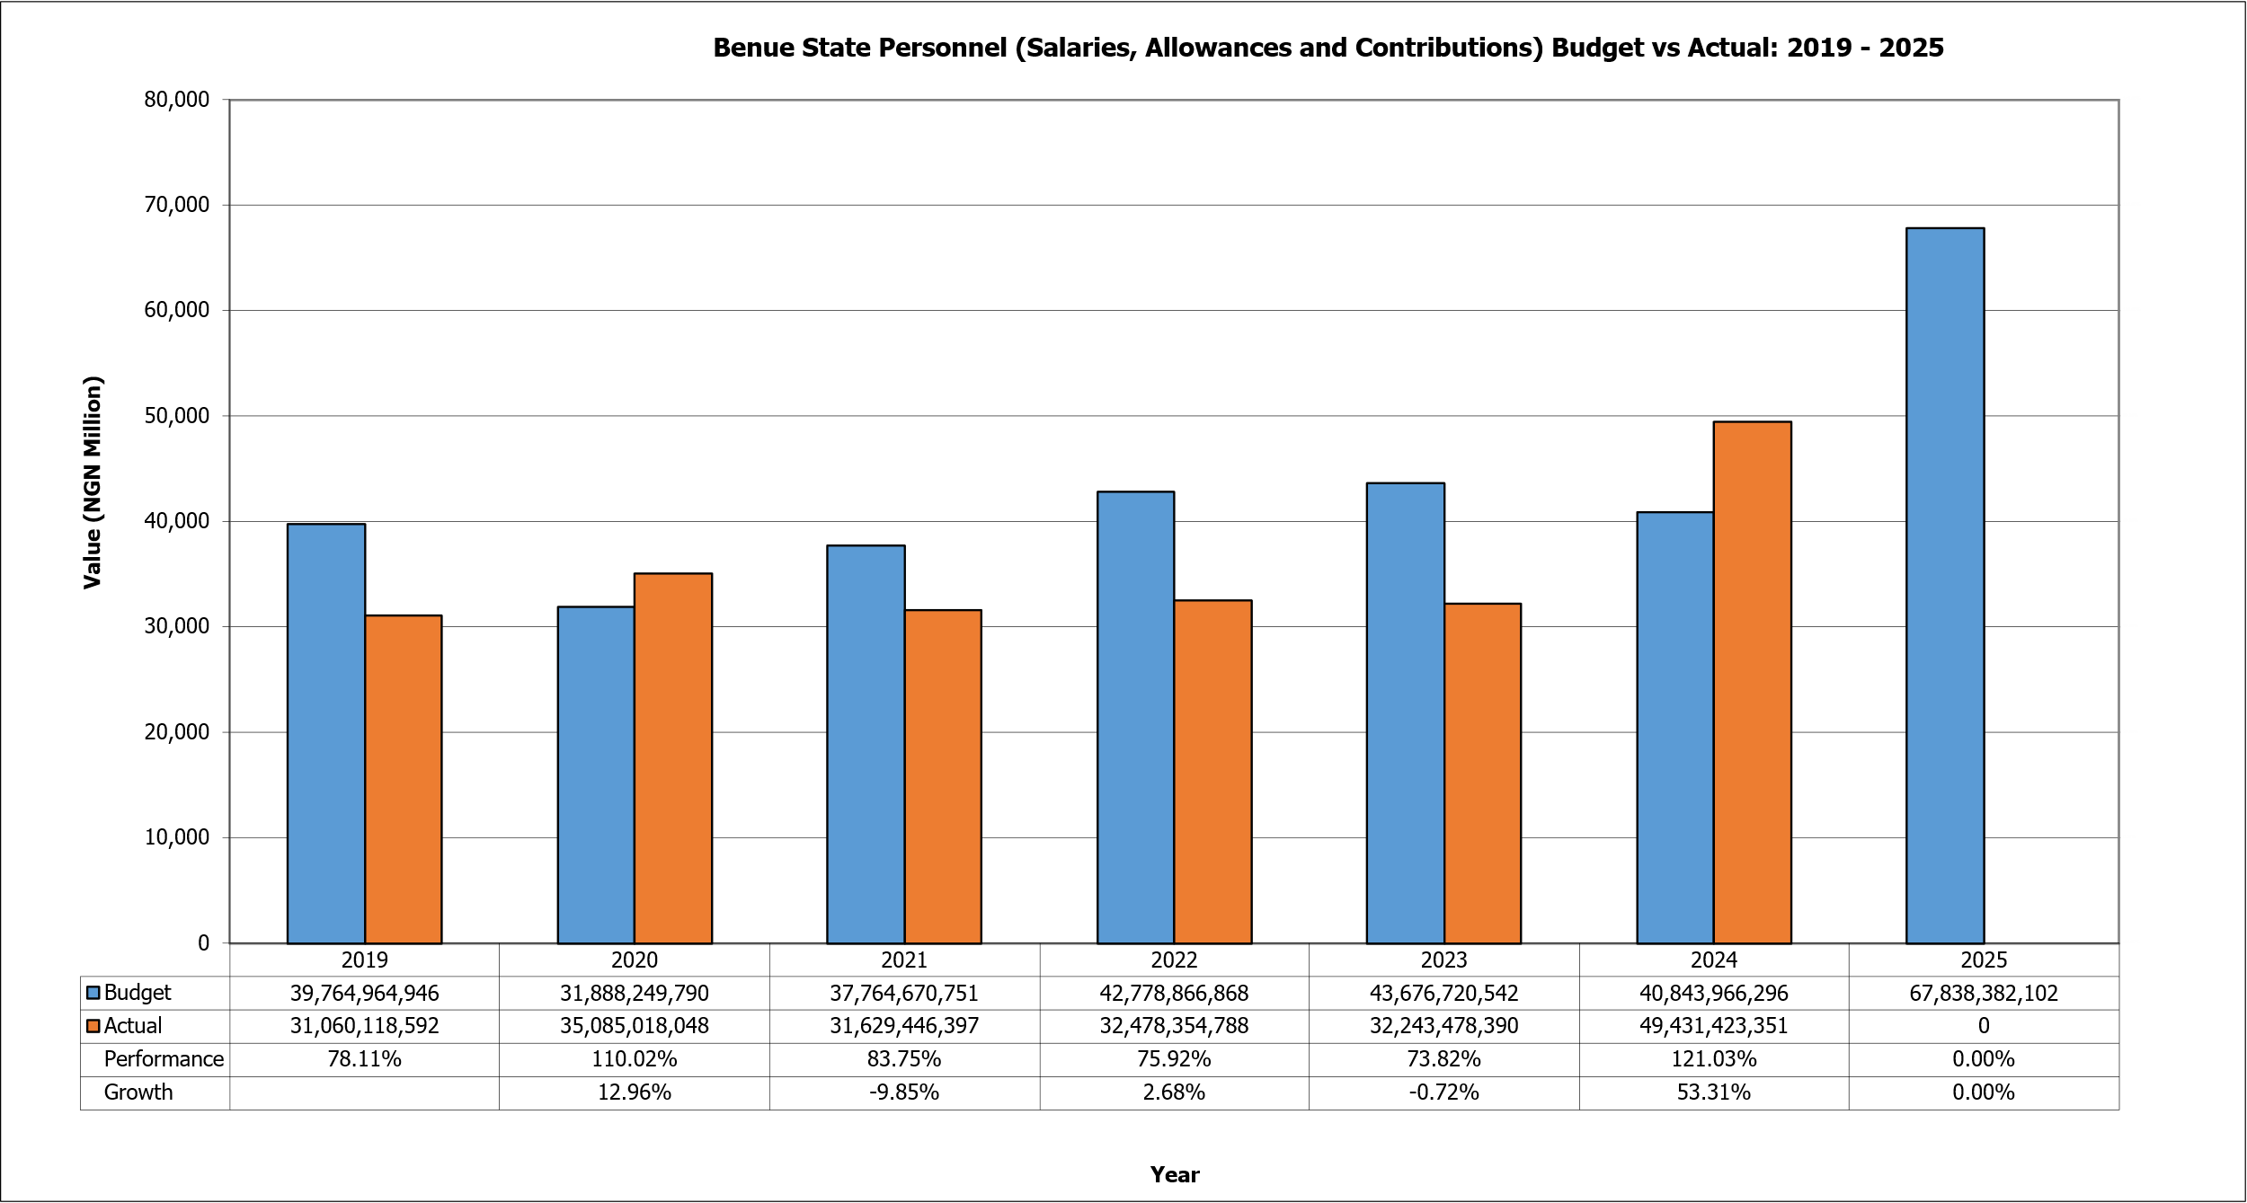
- Figure 9 shows the Benue State personnel (salaries, allowances, and contributions) budget versus actual expenditures from 2019 to 2025. In 2019, the budgeted amount was approximately ₦39.76 billion, while actual personnel costs stood at ₦31.06 billion. This translated to a performance of 78.1%, indicating that while most of the budgeted amount was utilised, there was still a shortfall in spending relative to projections. By 2020, although the personnel budget was reduced to ₦31.89 billion, actual expenditure surged to ₦35.09 billion, giving a performance rate of 110.02%. This overshoot of the budget suggests higher-than-expected personnel-related obligations that pushed spending beyond planned levels. In 2021, the personnel budget was slightly raised to ₦37.76 billion, but actual spending declined to ₦31.63 billion, representing a performance of 83.75%. This reversal indicates tighter control over personnel costs or possible delays in the disbursement of salaries and allowances. By 2022, the personnel budget rose further to ₦42.78 billion, yet actual expenditure amounted to ₦32.48 billion, producing a performance rate of 75.92%. The relatively low execution rate in this year suggests persistent expenditure constraints, perhaps linked to revenue shortfalls or deliberate efforts to manage the wage bill. The year 2023 showed a similar pattern of underperformance. Against a budget of ₦43.68 billion, the State spent ₦32.24 billion, yielding a performance of 73.82%. However, in 2024, the budget was set at ₦40.84 billion, but the actual personnel spending increased to ₦49.43 billion. This resulted in a performance rate of 121.03%, marking the highest overshoot in the period under review. The sharp increase likely stemmed from the increase in the minimum wage that was implemented in 2024. For 2025, the personnel budget is projected at a record ₦67.84 billion. From above, personnel spending overshooting in 2020 and 2024 is an indication of the challenges of managing personnel costs, which often fluctuate in response to policy changes, labour negotiations, and arrears payments.
Figure 10: Social Benefits
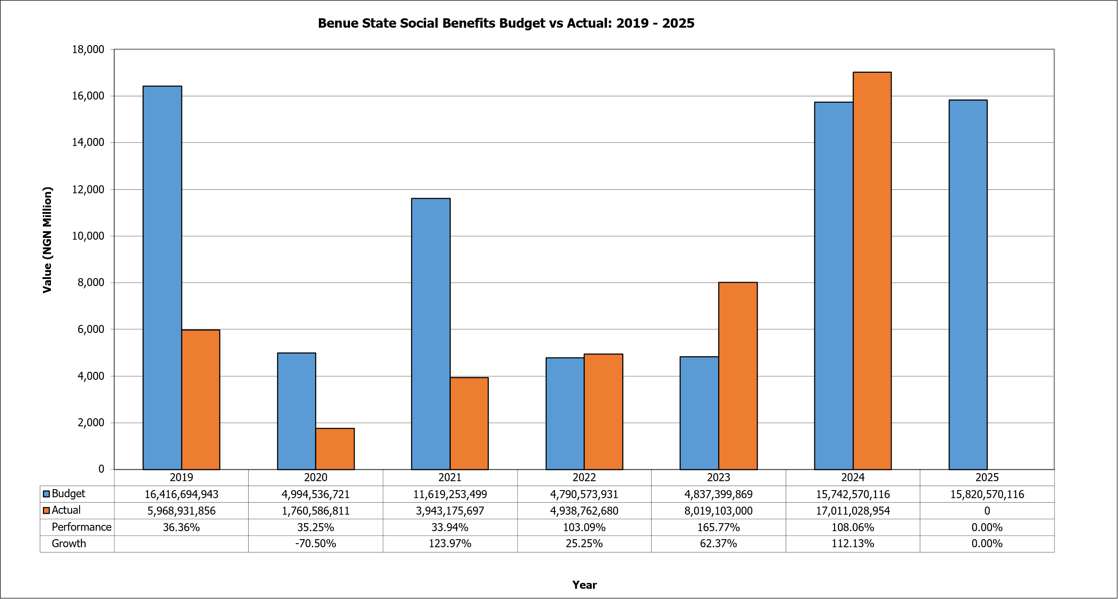
- Figure 10 shows the Benue State social benefits budget versus actual expenditures from 2019 to 2025. In 2019, the State budgeted approximately ₦16.42 billion for social benefits, but actual spending reached only ₦5.97 billion. This resulted in a performance rate of 36.36%. In 2020, the budget was cut drastically to ₦4.99 billion, yet actual spending stood at only ₦1.76 billion, producing a performance rate of 35.25%. This contraction in both budget and actual spending signalled fiscal tightening and a steep 70.5% decline in growth, pointing to difficult economic circumstances and possible reprioritisation away from social benefit allocations. The situation began to improve in 2021, when the budget was raised to ₦11.62 billion, though actual spending amounted to just ₦3.94 billion. This represented a modest performance of 33.94%, yet growth surged by 123.97% compared to the previous year. In 2022, the budget fell sharply again to ₦4.79 billion, but this time, actual expenditure of ₦4.94 billion slightly exceeded the budget. This yielded a performance rate of 103.1%, marking the first time within the period under review that actual spending surpassed planned allocations. The overshoot suggested a strong policy emphasis by the State to pay pensions and gratuity of retired civil servants and other public servants.
- By 2023, the upward trend continued as the State budgeted ₦4.84 billion for social benefits but ended up spending ₦8.02 billion. This translated into a performance rate of 165.77% and a growth rate of 62.37%, indicating significant scaling up of spending on pensions and gratuity well beyond initial projections. The momentum carried into 2024, when ₦15.74 billion was budgeted and actual expenditure rose further to ₦17.01 billion, resulting in a performance rate of 108.06%. For 2025, the budget has been set at ₦15.82 billion. However, as of reporting, no actual expenditures have been recorded.
Figure 11: Overheads
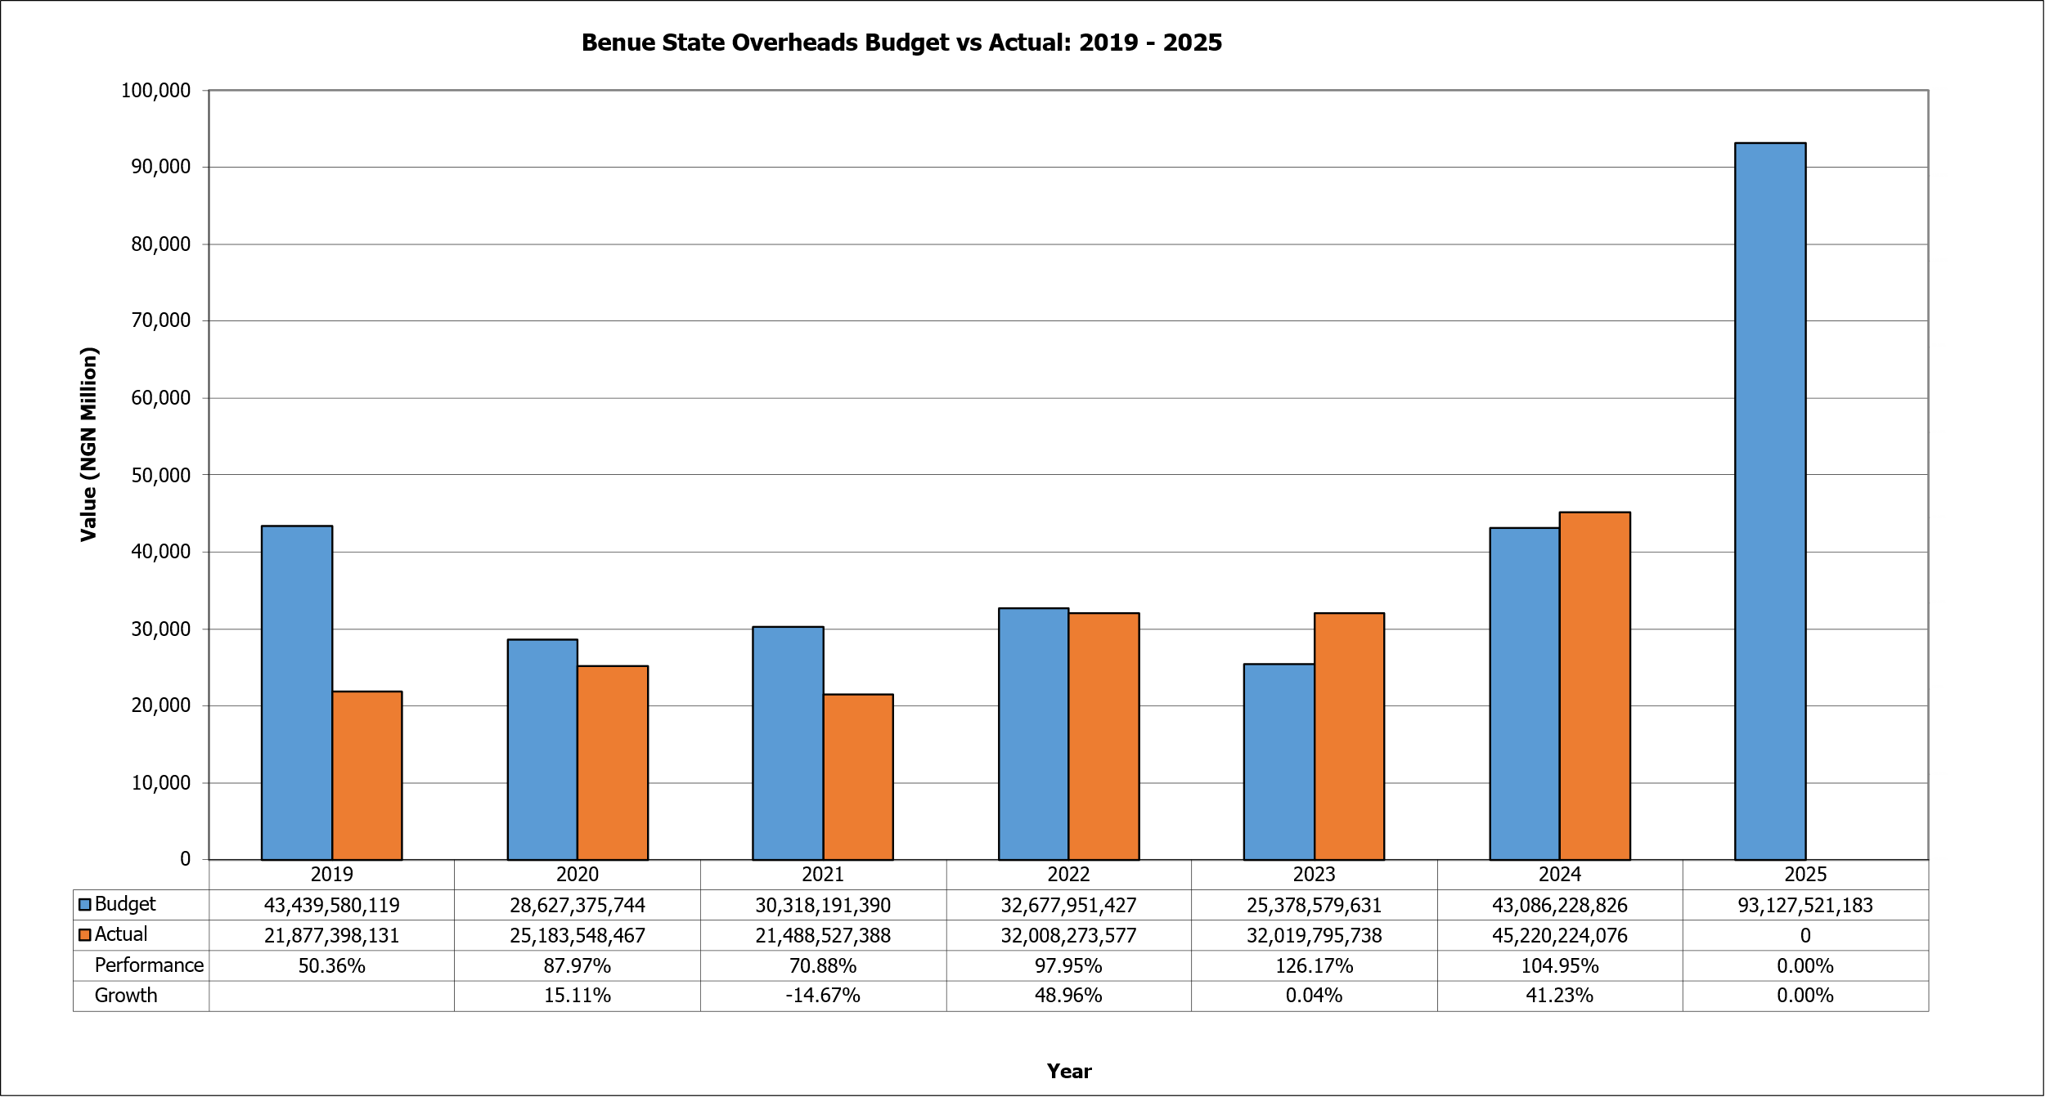
- Figure 11 shows the Benue State overheads budget versus actual expenditures from 2019 to 2025. In 2019, the State budgeted approximately ₦43.44 billion for overheads, but actual expenditure reached only ₦21.88 billion. This translated into a performance rate of 50.36%, showing that less than half of the projected overhead spending was actualised. In 2020, however, the budget was cut back to ₦28.63 billion, while actual spending stood at ₦25.18 billion. This produced a stronger performance rate of 87.97% and reflected a 15.11% growth, suggesting better budget alignment with actual disbursements. By 2021, the overhead budget was raised to ₦30.32 billion, yet actual expenditure declined slightly to ₦21.49 billion, resulting in a performance rate of 70.88% and a contraction of 14.67% in growth. This indicates the continued challenges in fully implementing overhead allocations despite higher budgetary provisions. The situation improved in 2022, when the overhead budget was ₦32.68 billion and actual expenditure rose sharply to ₦32.01 billion, leading to a performance rate of 97.95% and an impressive 48.96% growth. By 2023, however, the budget was reduced to ₦25.38 billion while actual overheads remained high at ₦32.02 billion. This overshoot pushed performance to 126.17%, signalling that overhead spending outpaced planned allocations, perhaps due to rising administrative and operational costs. The upward trend persisted in 2024, when ₦43.09 billion was budgeted, but actual spending rose further to ₦45.22 billion. This gave a performance rate of 104.95% and 41.23% growth, showing that overhead costs continued to increase. For 2025, the budget has been set at ₦93.13 billion.
Figure 12: Grants, Contributions, Subsidies, Transfers
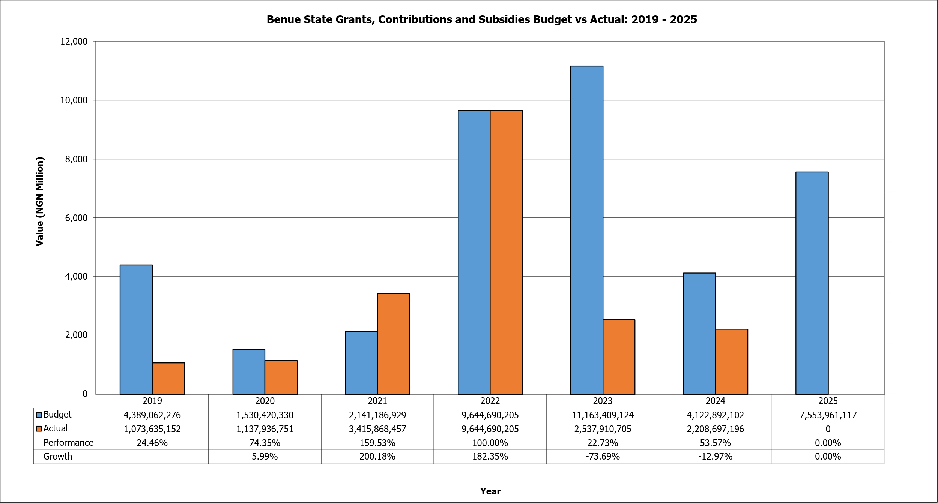
- Figure 12 shows the Benue State grants, contributions and subsidies budget versus actual expenditures from 2019 to 2025. As depicted in Figure 12, Actual performance over budget was 24.46% in 2019, rose to 74.35% in 2020, rose significantly to 159.53% in 2021 and 100% in 2022, and dropped significantly to 22.73% in 2023 and 53.57% in 2024. The spike in the amount budgeted and spent by the State in 2022 was due to the State's special poverty alleviation programme. The programme did not continue in 2023, hence the drop in actual performance.
Figure 13: Public Debt Service
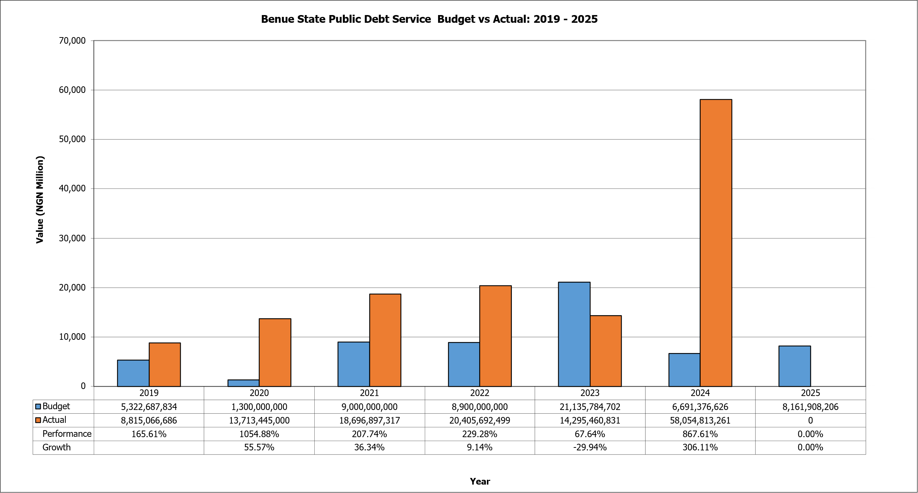
- Public Debt Charge includes payment for internal and external debts (principal and interest). As shown in Figure 13, performance exceeded the target in 2019, 2020, 2021, 2022, and 2024 (i.e., 165.61%, 1,054.88%, 207.74, 229.28% and 867.61%respectively). However, performance was less than tarry in 2023 (i.e., 67.64%). The State recorded a spike in debt servicing costs in 2024 with the payment of N58.05 billion.
Figure 14: Capital Expenditure
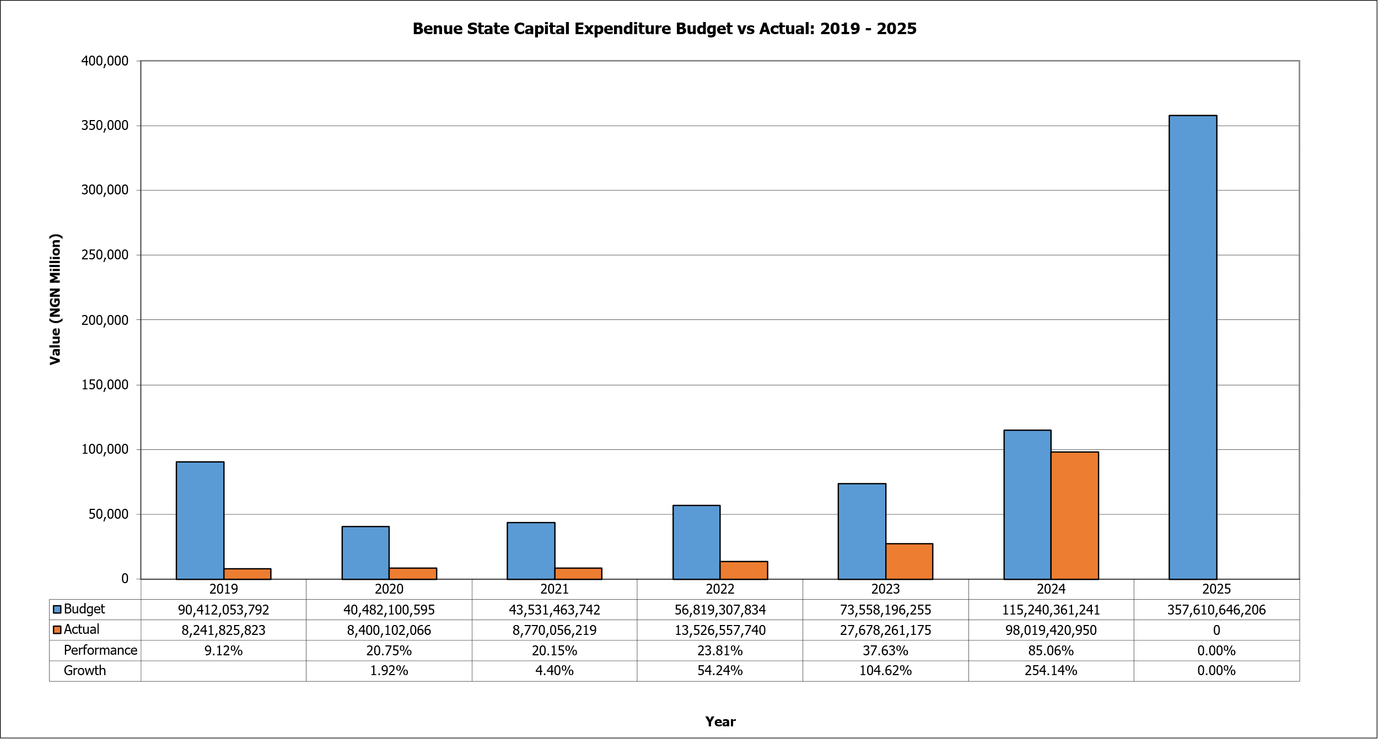
- Figure 14 shows the Benue State capital expenditure budget versus actual performance from 2019 to 2025. In 2019, the State budgeted approximately ₦90.41 billion for capital projects, but only ₦8.24 billion was actually spent. This translated into a performance rate of just 9.12%, reflecting a very wide gap between plans and implementation. In 2020, the capital expenditure budget was reduced sharply to ₦40.48 billion, while actual spending increased slightly to ₦8.40 billion. This gave a performance rate of 20.75% and a modest growth of 1.9% compared to the previous year. Despite the adjustment in budget size, the State continued to struggle with underperformance in capital project execution. In 2021, the capital budget rose slightly to ₦43.53 billion, but actual spending stood at ₦8.77 billion, yielding a performance rate of 20.15%. This represented only 4.4% growth, showing limited improvements in capital expenditure delivery. The trend improved significantly in 2022, when ₦56.82 billion was budgeted, and ₦13.53 billion was actually spent, leading to a performance rate of 23.81%. This represented a 54.24% growth in actual spending, signalling a stronger push toward capital investment, though the execution rate remained far below budgeted levels.
- By 2023, capital expenditure rose to ₦73.56 billion, and actual spending more than doubled to ₦27.68 billion. This marked a performance rate of 37.63% and a growth rate of 104.62%, showing the most significant expansion in capital spending up to that point. The trend peaked in 2024, when the budget allocation surged to ₦115.24 billion, and actual spending climbed to ₦98.02 billion. This translated into a performance rate of 85.06% and a growth rate of 254.14%, indicating a remarkable turnaround in capital project delivery and suggesting stronger fiscal commitment or improved financing capacity for infrastructure and development projects. For 2025, the capital budget is projected at an unprecedented ₦357.61 billion, the highest within the review period. From above, the trend in capital expenditure between 2019 and 2025 reveals persistent underperformance in the early years, followed by a dramatic surge in 2023 and 2024. This shift highlights the increasing priority given to capital investment in recent years.
Figure 15: Recurrent: Capital Expenditure Ratio
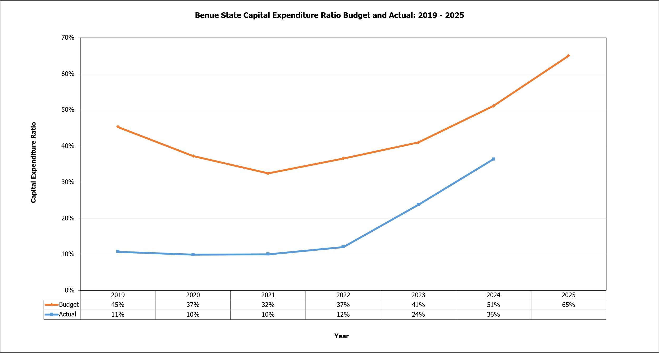
- Figure 13 presents the trend of the capital expenditure ratio in Benue State, comparing budgeted allocations with actual outcomes between 2019 and 2025. The data shows a consistent divergence between the budgeted expectations and the actual performance. In 2019, the State projected that 45% of its expenditure would be allocated to capital investments, but only 11% actual expenditure was on capital expenditure. This gap reflects the State’s limited capacity to translate fiscal priorities into real developmental spending, with most funds channelled instead toward recurrent obligations. The following years reflect a similar trend of underperformance in capital expenditure ratios. In 2020, the budgeted ratio fell to 37%, while the actual ratio slightly decreased to 10%. The trend of low capital expenditure suggests that the State remained heavily burdened by recurrent costs such as salaries, pensions, and overheads, leaving little fiscal space for infrastructure and developmental projects. The ratio narrowed further in 2021, when the budgeted target dropped to 32%, but the actual remained stagnant at 10%. These three consecutive years reflect a structural imbalance in public finance, where recurrent obligations consistently crowded out developmental investments.
- From 2022 onward, a gradual shift began to emerge. The budgeted ratio was 37%, but the actual rose modestly to 12%, suggesting a slow but deliberate attempt to rebalance expenditure priorities. In 2023, the capital ratio budgeted was 41%, while the actual ratio more than doubled to 24%. This marks a significant change in the pattern, indicating increased commitment toward capital investments and possibly improved fiscal capacity to fund infrastructure projects. The momentum strengthened further in 2024, when the budgeted ratio rose to 51% and the actual ratio reached 36%. This sharp increase reflects the most successful alignment between budgeted and actual capital spending in the review period, pointing to better fiscal discipline, stronger revenue mobilisation, or improved access to financing. The trend continues into 2025, where the State projects a capital expenditure ratio of 65%, the highest in the period.
Figure 16: Sector Expenditure Trend
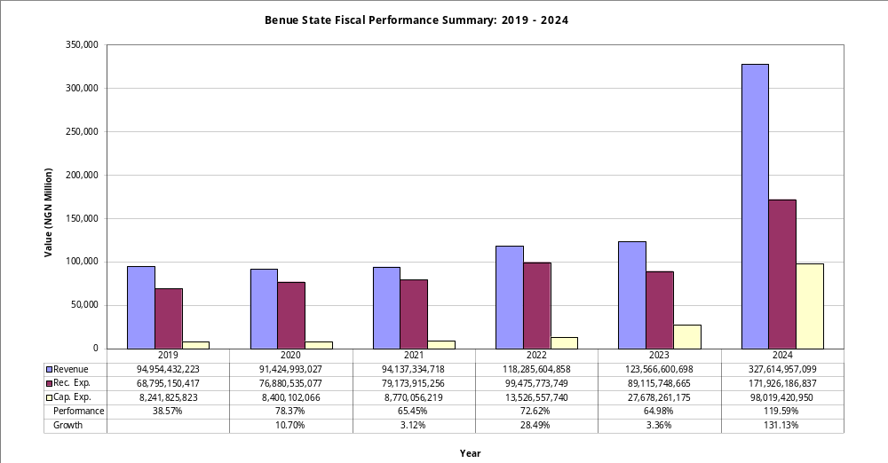
- In summary, Benue State’s fiscal performance ranges between 38.57% and 131.13% as depicted in Figure 16. The lowest performance was recorded in 2016, while the highest performance was recorded in 2024, significantly due to impressive revenue performance, particularly FAAC receipts. To sustain the impressive performance of 2024, the state must continue to increase domestic revenue mobilisation, leveraging the new tax reforms introduced by the Federal Government, improve expenditure and risk management, and improve the governance and investment climate of the state to attract new investment opportunities and development/donor support.
By Sector
- Analysis of both personnel, overhead & capital budget, and actual expenditure with performance indicators for all sectors from 2019 to 2024 is presented in the Tables below.

Table 4: Sector Expenditure – Budget Vs Actual
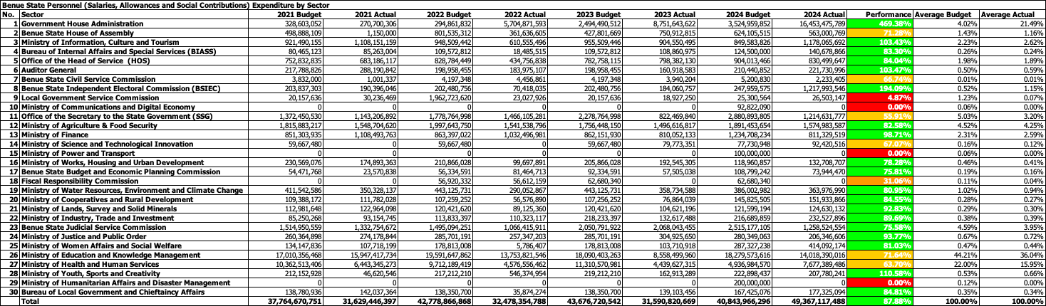
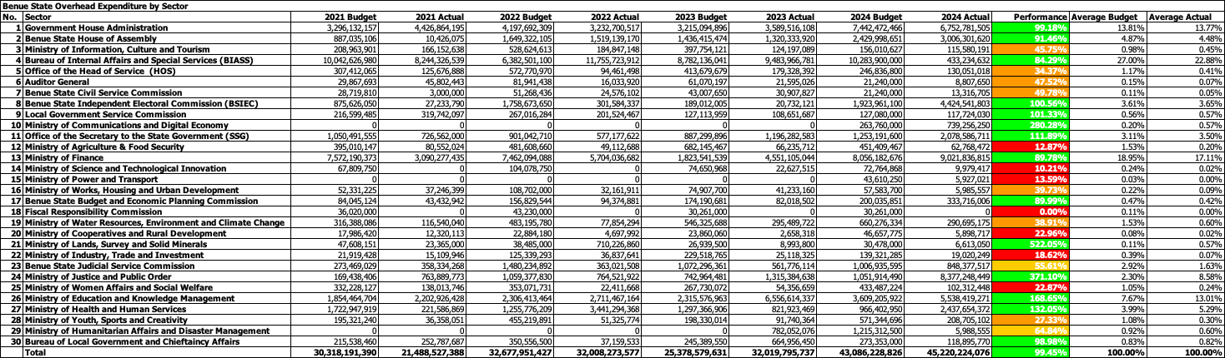
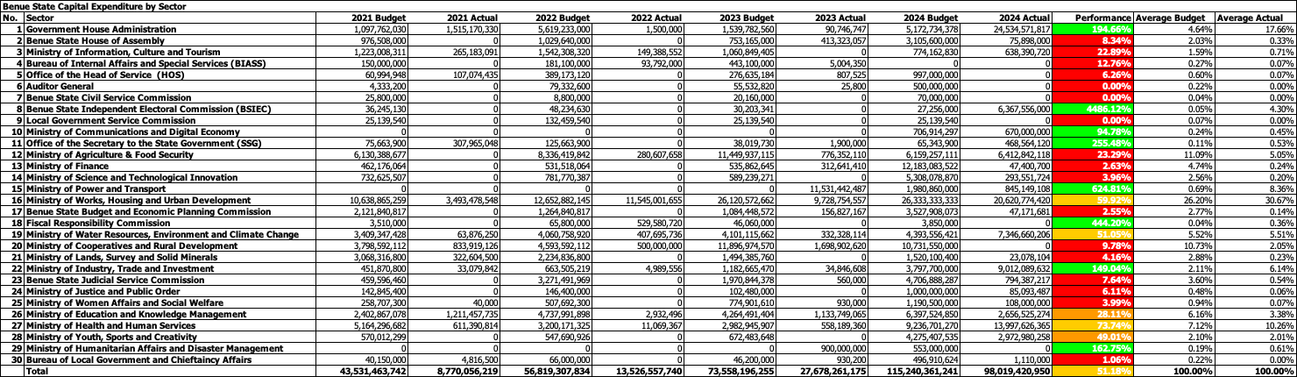

Debt Position
- A summary of the consolidated debt position for Benue State Government is provided in the table below.
Table 5: Debt Position as at 31st December 2024
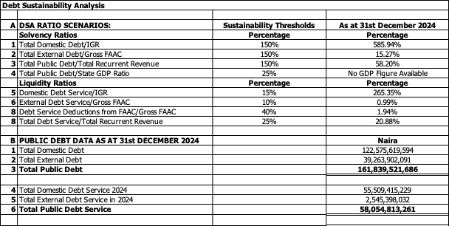
- Table 7 presents the debt sustainability analysis (DSA) of Benue State as of 31st December 2024, disaggregating solvency ratios, liquidity ratios, and overall public debt data. The solvency indicators reveal a mixed picture. The ratio of total domestic debt to internally generated revenue (IGR) stands at a staggering 585.94%, far exceeding the sustainability threshold of 150%. This indicates that the State’s domestic debt burden is disproportionately high relative to its ability to generate revenue internally, suggesting a heavy reliance on borrowing rather than homegrown revenue sources. On the other hand, external debt to gross FAAC (federation account allocation) is 15.27%, which falls comfortably within the sustainability benchmark of 150%. Similarly, total public debt to recurrent revenue stands at 58.20%, well below the threshold of 150%, suggesting that despite high domestic debt exposure, the State’s overall debt relative to recurrent revenue remains within manageable levels.
- Turning to liquidity ratios, the analysis paints a concerning picture, especially with respect to domestic debt service. The ratio of domestic debt service to IGR is 265.35%, significantly breaching the recommended ceiling of 15%. This indicates that the internally generated revenue in the State is grossly insufficient to cover its domestic debt service obligations, highlighting acute fiscal stress. Conversely, external debt service to gross FAAC is only 0.99%, well below the 10% benchmark, implying that external debt obligations remain manageable and pose no immediate liquidity threat. Debt service deductions from FAAC as a share of gross FAAC stand at 1.94%, which is also within the permissible threshold of 40%. In addition, total debt service to recurrent revenue is recorded at 20.88%, which, though below the ceiling of 25%, signals that about one-fifth of recurrent revenue is already being absorbed by debt servicing. This reduces fiscal space for recurrent obligations such as salaries, pensions, and overheads.
- Section B of the table presents the absolute figures for the public debt in Benue State as of December 2024. The total domestic debt amounts to ₦122.58 billion, while total external debt is ₦39.26 billion, bringing the aggregate public debt to ₦161.84 billion. Debt servicing remains a critical issue, with ₦55.51 billion spent on domestic debt service and ₦2.55 billion on external debt service, amounting to a combined ₦58.05 billion in total debt service obligations for the year. This debt service burden is disproportionately skewed toward domestic debt, which accounts for over 95% of the total. The scale of domestic debt servicing relative to revenues suggests that Benue State’s fiscal stability is heavily undermined by high interest payments and short-term borrowing pressures. From above, Benue State’s overall debt-to-revenue indicators appear moderate when viewed against external benchmarks. The composition and servicing profile of the debt raise serious concerns. The excessive reliance on domestic borrowing, coupled with unsustainable debt service ratios relative to internally generated revenue, highlights structural weaknesses in revenue mobilisation and fiscal discipline. The relative comfort in external debt indicators reflects cautious foreign borrowing, but this does not offset the risks posed by the ballooning domestic obligations.

Fiscal Strategy Paper

Macroeconomic Framework
- The Macroeconomic framework is based on:
Figure 17: Benue State Macroeconomic Framework
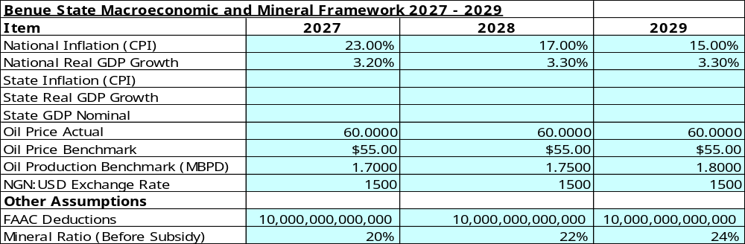

Fiscal Strategy and Assumptions

Policy Statement
The Benue State Government is dedicated to mobilising its citizens to harness the state’s rich agricultural, human, and natural resources to foster sustainable wealth creation, promote individual prosperity, collective development, and peaceful coexistence in a secure, transparent, and accountable environment. Guided by the Benue State Fiscal Responsibility Law 2020, Part V, Section 22(1), the state’s fiscal policy for 2026-2028 emphasises aggregate fiscal discipline, allocative efficiency, and effective spending to position Benue as a leading agricultural and economic hub, leveraging its status as the “Food Basket of the Nation”.

Objectives and Targets
- The key targets from a fiscal perspective are:
- Expenditure Optimisation: Streamline personnel and overhead costs to allocate at least 45% of the annual budget to capital development, prioritising agriculture, rural infrastructure, and healthcare.
- Internally Generated Revenue (IGR) Growth: Achieve a 12% annual IGR increase by improving tax administration, adopting digital revenue platforms, and tapping into agriculture, solid minerals, and eco-tourism.
- Prudent Debt Management: Limit borrowing to capital expenditure projects with high economic returns, ensuring compliance with the Benue State Fiscal Responsibility Law 2020 and maintaining debt-to-revenue ratios within sustainable limits.
- Diversified Capital Financing: Secure at least 15% of capital receipts from non-loan sources, such as Public-Private Partnerships (PPPs), grants, and development partner funding, by 2028.
- Project Completion Focus: Complete 75% of ongoing capital projects (e.g., irrigation systems, agro-processing facilities, rural roads) before starting new projects to maximise impact and fiscal efficiency.
- Economic Growth through Agriculture: Drive a 4% annual increase in state GDP by investing in agriculture (rice, yams, cassava, soybeans) and agro-allied industries, supported by value chain development.
- Fiscal Transparency: Introduce the State Integrated Financial Management Information System (SIFMIS) to ensure real-time budget monitoring and management, public access to fiscal data, and compliance with statutory reporting requirements.
- Agricultural Modernisation: Allocate 20% of capital expenditure to agricultural transformation, including mechanisation, irrigation, and Agricultural Development Zones (ADZs) to boost commercial farming and exports.
- Climate Resilience: Invest in flood control infrastructure, drought-resistant crops, and solar-powered irrigation to safeguard agricultural productivity, targeting a 10% reduction in climate-related economic losses by 2028.
- Social Inclusion: Expand social investment programs, such as youth and women empowerment initiatives and microfinance schemes, reaching 80,000 beneficiaries annually to reduce poverty and unemployment.
- Digital Revenue Systems: Implement digital tax collection and expenditure tracking platforms to reduce revenue leakages by 25% and enhance fiscal transparency by 2028.
- Solid Minerals and Tourism: Develop frameworks for sustainable mining (e.g., limestone, kaolin) and eco-tourism, targeting 3% of IGR from these sectors by 2028.
- Security for Economic Stability: Strengthen security through community policing and surveillance systems to support agricultural and economic activities, allocating 5% of the budget to security infrastructure.
- Stakeholder Engagement: Establish a Fiscal Strategy Implementation Committee with private sector, civil society, and community representation to ensure inclusive policy execution and accountability.

Indicative Three-Year Fiscal Framework
- The indicative three-year fiscal framework for the period 2026-2028 is presented in the table below.
Table 6: Benue State Medium Term Fiscal Framework
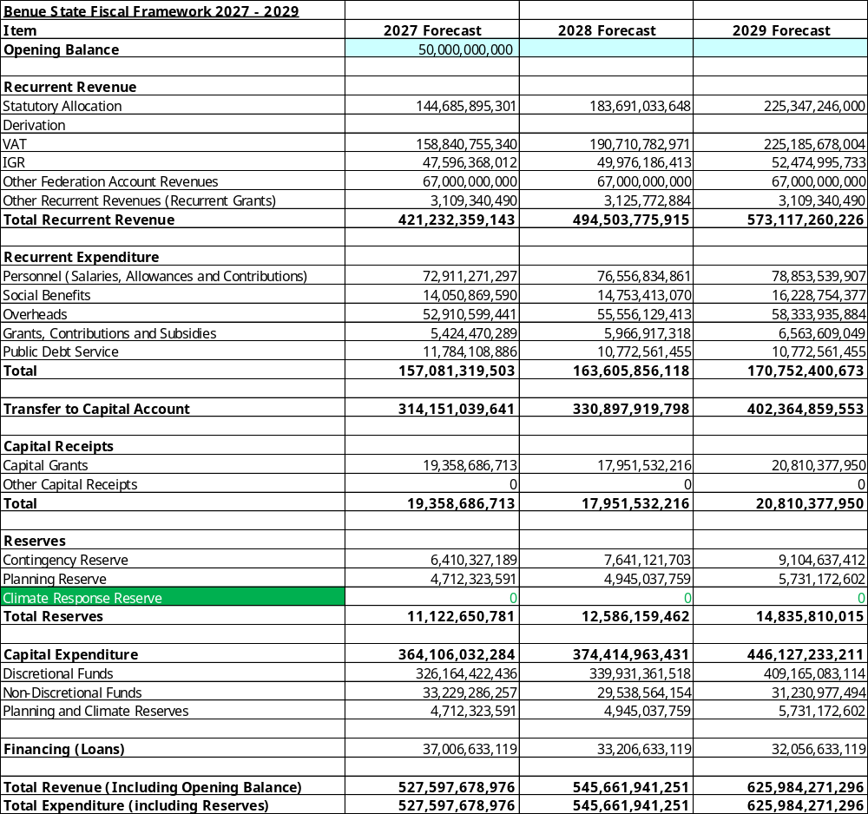

Assumptions
- Statutory Allocation – The forecast for the statutory allocation is based on the benchmarked oil price, exchange rate, and the oil production Benchmark for the 3 years indicated in Section 3. A. However, this is in line with the advisory note on the 2026-2028 macroeconomic framework provided by the Nigerian Governors Forum. The FGN, 2026-2028 MTEF/FSP is yet to be finalised. However, the State will continue to monitor to ensure that the assumptions are consistent with the assumptions that will be in the FGN 2026-2028 MTEF/FSP.
- VAT – The elasticity techniques based on the macroeconomic assumptions as explained above and on the assumption that the VAT rate will remain at 7.5% were used to forecast VAT for 2026-2028. This forecast also noted that the State’s share of the VAT will increase from 50% to 55% and other emerging issues with the new Tax Acts on the mode of sharing across the States.
- Other Federation Account Receipts – The estimation for other federation account receipts is based on the own value forecast, calculating the anticipated receipts for 2026, 2027 and 2028. More importantly, the State considered the dynamics around the current year receipts so far and used them to estimate receipts over the next three years.
- Internally Generated Revenue (IGR) – The current administration is improving on the ongoing measures to grow IGR. These measures, taken into consideration the impact of the new federal tax law due to take effect next year, are anticipated to yield results as actual IGR for the current year is increasing. It is anticipated that IGR will continue to increase by 15.5% in the current year and start to stabilise from 2027, with a minimum annual growth of 17.35% and 15% in 2028 and 15.90% 2029. Therefore, Own Percentage is used to forecast IGR for 2027 – 2029.
- Grants – The internal grants are based on the actual anticipated inflows, where the states have already signed a memorandum of understanding. External grants are also based on signed grant agreements with the development partners.
- Financing (Net Loans) – The Benue State intends to secure an external loan/borrowing of about N37 billion in 2026 (mainly from World Bank). However, the State is not planning to take any loan from Domestic Sources in 2026, due to the current adverse solvency and liquidity ratios around total domestic loans and domestic loans servicing costs.
- Personnel – The new minimum wage was operationalised in 2024, hence the spike in the actual personnel expenditure in 2024 (i.e., 53% increase from 2023 actual expenditure). However, it is anticipated that the trend will stabilise in 2025 and 2026. Own percentage forecast was used to forecast personnel costs for 2027, 2028, and 2029. The projection is that the total wage bill will increase by 12% in 2025, with a gradual increase of 10%, 5% and 3% over the 2026–2028 fiscal years.
- Social Benefits – A substantial amount of pensions and gratuity was owed by the State before the inauguration of the current administration. A substantial proportion of the outstanding social benefits costs was paid in 2024, resulting in an increase of 112% from the 2023 actual expenditure. It is anticipated that there will be a reduction in social benefit costs in 2025 (i.e., -15%) and grow marginally in 2026, 2027 and 2028, which will be owed as pension and gratuity payments. Hence, the social benefits will increase by 12%, 5% and 10% in 2027, 2028 and 2029.
- Overheads – Overhead actual performance was relatively unstable between 2019 and 2021 before stabilising in 2022 and 2023. However, the actual performance ballooned in 2024 due to the high level of inflation recorded in the country in 2024, which increased overhead expenditures. It is anticipated that overhead costs will remain stable going forward, as the inflation rate is more stable. Consequently, the own percentage method is used to forecast overhead for 2027, 2028 and 2029 (5% applied for each year).
- Grants, Contributions, Subsidies and Transfers – Grants. Contributions, subsidies and transfers forecast for 2026, 2027, and 2028 were based on the current performance of this main expenditure class for 2025. It is anticipated that the performance for 2025 will increase by 60% over the 2024 actual. The own percentage growth of 20%, 10% and 10% for 2026, 2027 and 2028 were used, factoring in promotion of staff and salary notch increases.
- Public Debt Service - is based on the projected principal and interest repayments in the Benue State Debt Sustainability Analysis document for 2026, 2027 and 2028.
- Contingency and Planning Reserves – The contingency reserve is estimated at 2% of the total capital expenditure for the plan period. The contingency reserve will not be allocated for any specific expenditure line, as the fund will be for any unforeseen event that may arise during the fiscal year. The planning reserve is estimated at 1% of recurrent revenue. The planning reserve will be allocated to specific recurrent and capital expenditure items during the bilateral discussion stage before the budget is presented to the State House of Assembly.
- Capital Expenditure – is based on the balance from the recurrent account plus capital receipts, less reserves (contingency and planning) as outlined above.

Fiscal Trends
- Based on the above envelope, plus actual figures for 2019-2026 (using the same basis for forecasting as noted in the sub-sections within section 3.B), the trend from historical actual to forecast can be seen for revenue and then expenditure in the line graphs below.

Figure 18: Benue State Revenue Trend
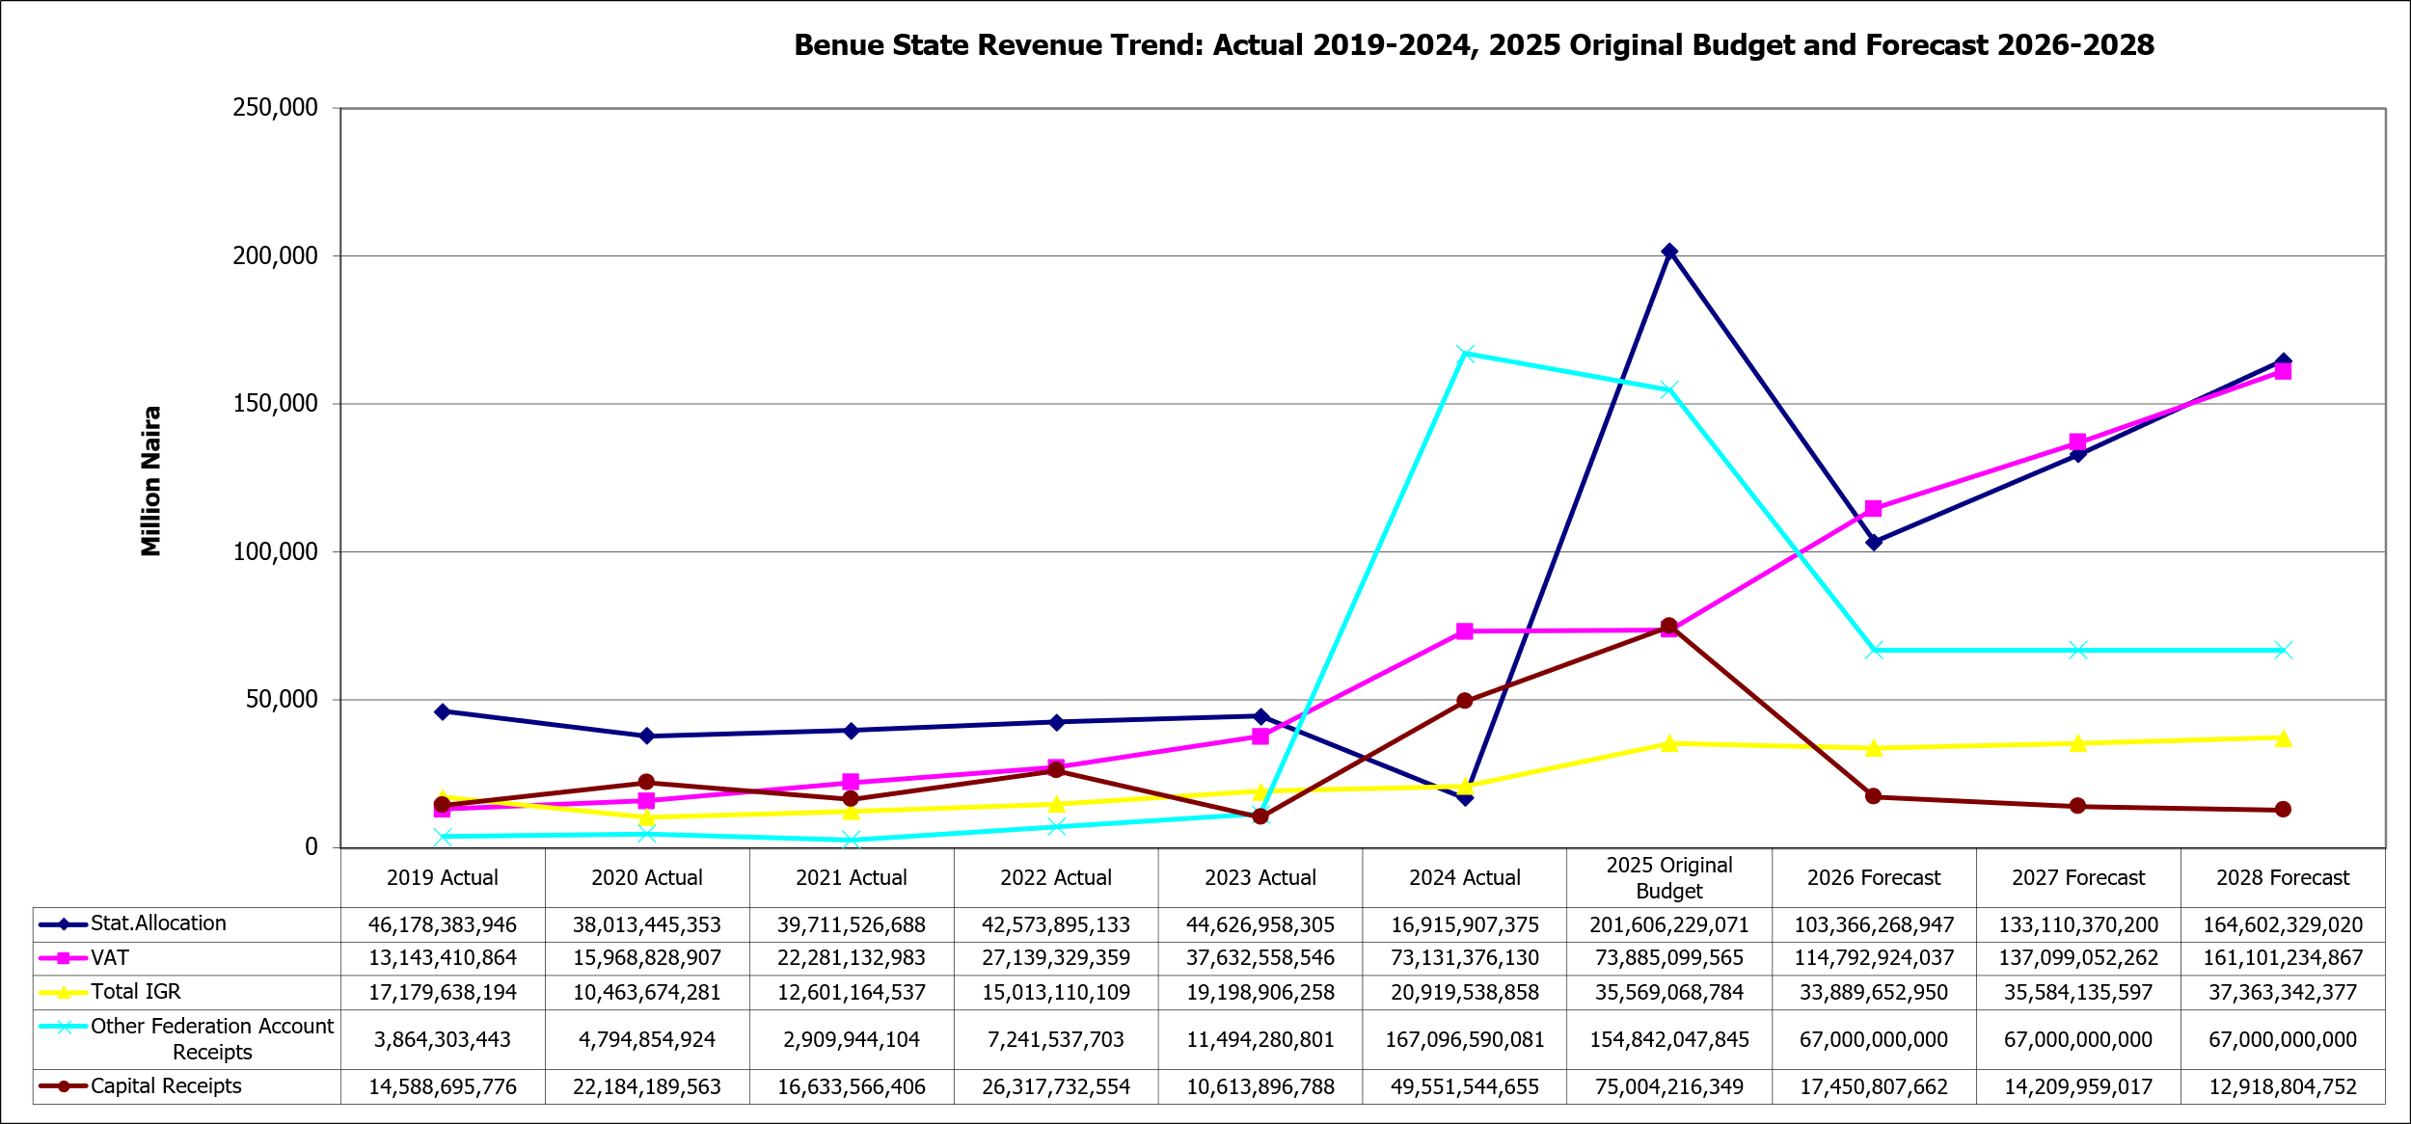
Figure 19: Benue State Expenditure Trend
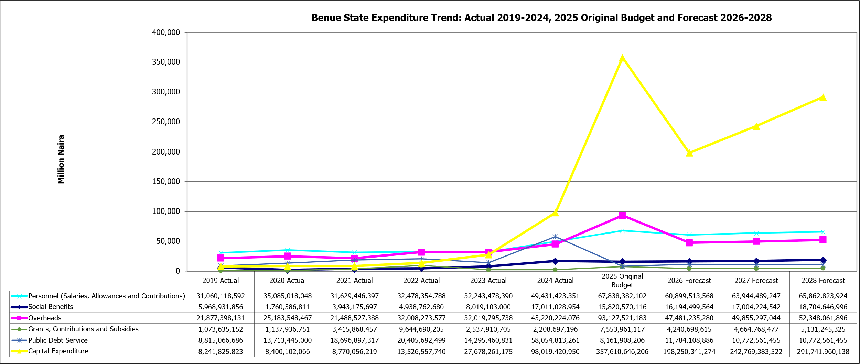

Local Government FAAC and IGR Estimates
- Based on the macroeconomic and mineral sector assumptions in the sections 3.A-3.C and above and the latest horizontal and vertical sharing ratios, Table 7 below provides estimates of the FAAC revenues and share of State IGR for the 23 Local Governments of Benue State.
Table 7: LG FAAC and IGR Estimates 2026 – 2028
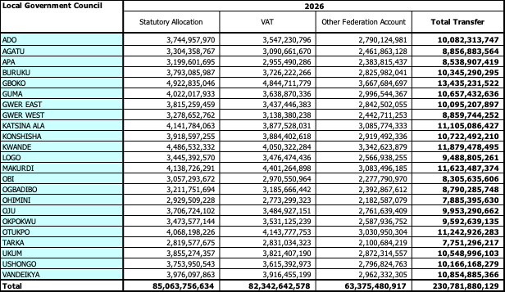

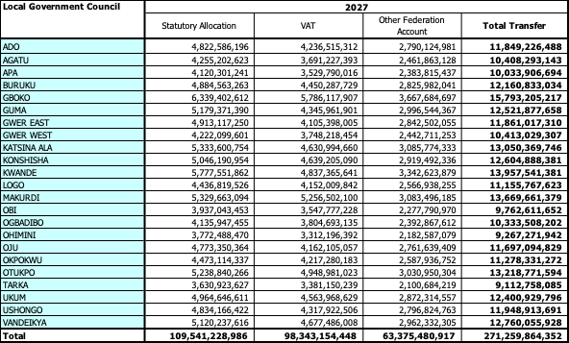
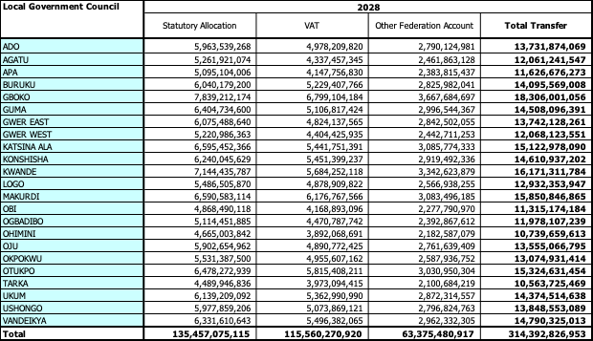

Fiscal Risks
- The analysis and forecasting basis as laid out above implies some fiscal risks, including but not limited to:
Table 8: Fiscal Risks
Risk | Likelihood | Impact | Reaction
Disruptions in agricultural production due to invasion of natives by herders, climate variability, or supply chain issues may lead to reduced output and revenue. | Medium | High | Dependence on Statutory Allocation is crucial to the budget; however, clear prioritisation of projects in the capital budget is required. Increased IGR efforts to decrease reliance on federal transfers and seek alternative funding sources (grants, PPPs, etc.).
Security situation countrywide and within Benue State (e.g., herder’s invasion, banditry) could affect economic activity and agricultural output, resulting in risks to VAT and Statutory Allocation. | Medium | High | The estimates for VAT and Statutory Allocation are not overly ambitious. Clear prioritisation of projects in the capital budget is required. Increased IGR efforts to reduce reliance on federal transfers and explore alternative funding sources (grants, PPPs, etc.).
Risks associated with debt financing. | Low | Medium | Use of external borrowing to finance budget deficits, with strict adherence to debt sustainability frameworks.
Mismanagement and inefficient use of financial resources. | Medium | High | Adherence to existing and new institutional and legal/regulatory frameworks to ensure transparent and efficient use of financial resources.
Floods and other natural disasters are impacting economic activity and the IGR tax base, causing increased overhead expenditure. | Medium | Medium | Increased investment in climate resilience (flood control, irrigation), and enhanced disaster preparedness, adaptation, and awareness.
- It should be noted, however, that no budget is without risk. The ongoing implementation of the 2025 budget should be closely monitored, as should the security situation and impact of the fiscal and economic outlook.

Budget Policy Statement

Budget Policy Thrust
- The overall policy objectives for the 2026-2028 budget period for Benue State are captured by the following points:
  - Revenue Mobilisation & Fiscal Sustainability
- Strengthen Internally Generated Revenue (IGR) mechanisms through digital tax systems, land use charges, and SME levies
- Optimise Federal Account Allocation Committee (FAAC) inflows with improved fiscal discipline
- Expand Public-Private Partnerships (PPP) and attract donor funding (targeting the 4% external financing gap)
  - Inclusive Social Protection & Human Capital Development
- Implement the 5-year Social Protection Policy and Multisectoral Action Plan for Food and Nutrition
- Increase budgetary allocations to education, healthcare, and youth empowerment
- Launch targeted conditional cash transfers and school feeding programs in underserved communities
  - Agricultural Transformation & Food Security
- Invest in mechanised farming, irrigation systems, and agro-processing zones
- Support farmer cooperatives and access to credit through budget-backed guarantees
- Fund climate-resilient agriculture and extension services
  - Infrastructure & Urban Renewal
- Prioritise road rehabilitation, rural electrification, and water supply projects
- Allocate capital expenditure to urban renewal in Makurdi and secondary cities
- Leverage PPPs for housing, transport, and ICT infrastructure
  - Governance, Transparency & Citizen Engagement
- Adopt performance-based budgeting and quarterly budget performance reviews
- Publish citizen-friendly budget summaries and dashboards
- Institutionalise participatory budgeting with civil society and community leaders
  - Environmental Sustainability & Climate Action
- Budget for reforestation, flood control, and waste management
- Integrate climate adaptation into all capital projects
- Establish a Green Fund for eco-friendly initiatives

Sector Allocations (3 Year)
- The total forecasted budget size for the 2026 fiscal year as explained in Section 3.C above is N428,523,506,257 of which N140,600,055,913 is recurrent expenditure (i.e. Personnel, Overhead, Social Contributions, Special Programmes, Grants, Contributions and Subsidies, and Public Debt Charge), N283,164,981,337 will be for capital expenditure, and N4,758,469,007 will be for contingency reserve for unforeseen event that may occur during the fiscal year. A planning reserve of N3,721,581,864 provision was made, which will be allocated to sectors at the bilateral discussion stage to fund critical expenditure items not envisaged at the stage of issuing the budget call circular.
- Presented in the table below are the indicative three envelopes for sectors and sub-sectors.
Table 9: Indicative Sector Expenditure Ceilings 2027-2029
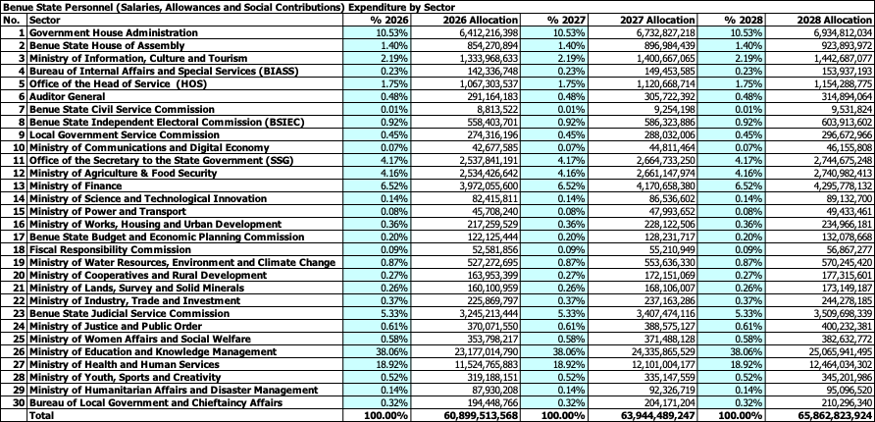
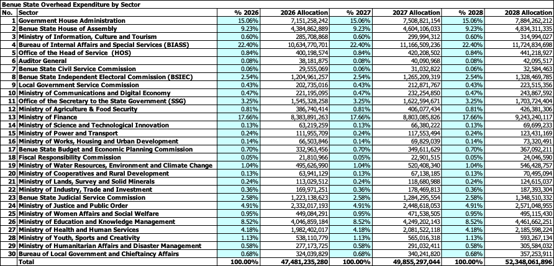
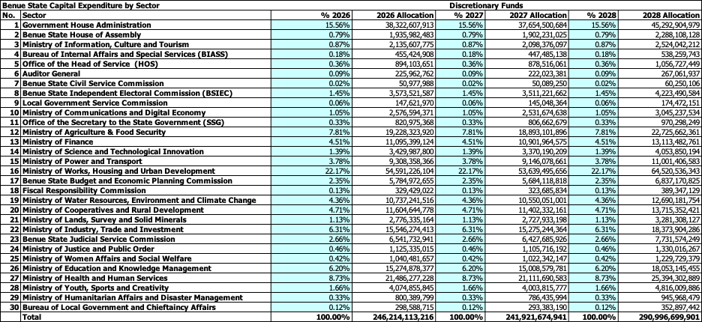
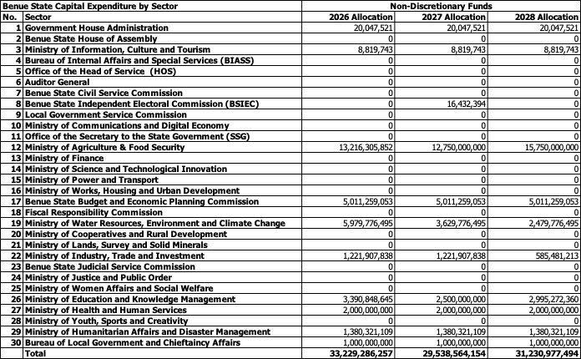
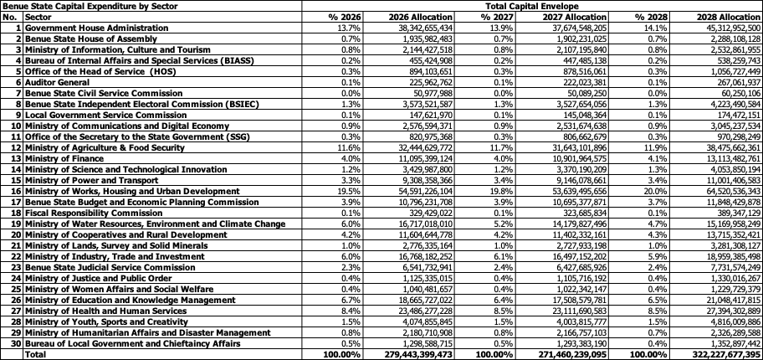

Considerations for the Annual Budget Process
- The budget call circular should include the following instructions to MDAs for the annual budget submissions:
- Only prioritised projects contained in the Health, Education, WASH, and Social Protection sectors’ MTSS should be in the MDA's budget proposal.
- Other MDAs should ensure detailed needs assessments for capital projects and strategic Consultation with the citizenry to back up each item of the Budget, in line with the Government's promise to ensure effective citizen engagement.
- Other MDAs' Budget submissions for capital projects must include full lifetime capital investment requirements (costs) and also sources of funding (particularly if grants and/or loans are being used to fund partially/fully the project).
- Finally, all MDAs are expected to ensure strict compliance with the National Chart of Accounts codes, Budget ceilings to ensure it is in line with MTEF and other highlights as indicated in the Benue State Budget Calendar.

Summary of Key Points and Recommendations
- We summarise below a list of the key points arising in this document:
- The draft MTEF document should be presented to the Executive Council (ExCo), and the Director-General/CEO Benue State Budget and Economic Planning Commission should present the final MTEF to the State House of Assembly (SHoA) for their review and approval in accordance with the Fiscal Responsibility Law (FRL).
- The State budget estimates should be based on the MTEF document, which has historically provided more realistic estimates than have been included in the Annual Budget.
- Loans expected to be drawn as capital receipts should be captured in the budget only when they have been approved and commitment fees are paid, and documentation is lodged with the Debt Management Office (DMO).
- For all loans, the precise impact on debt sustainability ratios should be assessed, and a detailed analysis of the impact of the associated expenditure (for example, Economic Analysis, Financial Analysis) is also undertaken to help justify the funding.

* = estimate
African Development Bank Group, African Economic Outlook, 2025 - Making Africa’s Capital Work Better for African’s Development.

